# **LAB 7 PROTOCOL: ECG (iWORX)**

## **Equipment Setup**

1. Connect the IWX/214 data unit to the computer using the USB cable to connect the computer to the USB port on the rear panel of the unit.
2. **The student should make sure that all jewelry from his/her wrists and ankles has been removed.**
3. Use an alcohol swab to clean a spot on each wrist and ankle that has little or no hair. Make sure these areas are dry before attaching the electrodes (in the next step).
4. Remove the plastic covering from five disposable electrodes and apply an electrode to the scrubbed area on one wrist. Repeat this for the other wrist and both ankles. Please note in step 5 (below) that two electrodes will be attached to the right wrist.
5. Attach the C-AAMI-504 cable with leads on the end of the gray patient cable to the Isolated Channel 1 & 2 input of the IWX/214 unit: **DO USE THE NON-ISOLATED CHANNEL 1 OR CHANNEL 2 INPUTS** (Figure 5)**.**

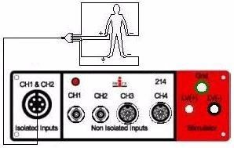

**Figure 5: Data acquisition connections.**

1. Attach the five color-coded electrode cables to the ground and Channel 1 inputs on the lead pedestal and snap the other ends onto the disposable electrodes, so that the:
   1. **red cable is attached to the right wrist.**
   2. **black cable is connected to the left wrist.**
   3. **white cable is connected to the right wrist.**
   4. **brown cable is connected to the left ankle.**
   5. **green cable (the ground) is connected to the right ankle.**
2. The student should sit quietly with their hands placed in their lap.

## **Start the Software**

1. Click the LabScribe icon on the Desktop.
2. When the program opens, select Load Group from the Settings menu.
3. When the dialog box appears, select IPLMV6Complete.iwxgrp. Click Load.
4. Click on the Settings menu again and select Human Heart----SixLeadECG.

After a short time, LabScribe will appear on the computer screen as configured by the SixLeadECG settings.

## **Activity 1. Obtain a 6-Lead ECG from a Resting Subject**

The aim is to record a 6-lead ECG from a resting subject and determine the PR Interval, QRS Duration, and QT Interval.

**Procedure**

1. Click Start, then click AutoScale on all the channels. If the R wave on Channel 1 or 2 is inverted, click Stop and check to see which electrodes the lead wires are attached to. Check the Equipment Setup section of this experiment. If a larger signal is required, the electrodes should be moved from the wrists to the skin immediately below each clavicle.
2. When you have a suitable trace, type “<Subject’s Name> resting ECG” on the comment line to the right of the Mark button. Press the Enter key on the keyboard to attach the comment to the data.
3. Click Stop to halt recording. Your data may look something like Figure 6.
4. Select Save As in the File menu and type a name for the file. Choose a destination on the computer in which to save the file (e.g. the iWorx or class folder). Click the Save button to save the file (as an *.iwd file).

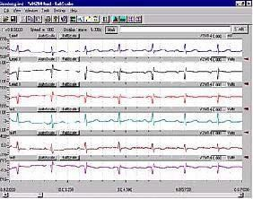

**Figure 6: 6-lead ECG generated by recording Leads I and II on Channels 1 and 2, respectively.**

### **Data Analysis**

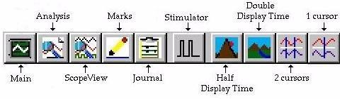

**Figure 7: The LabScribe toolbar.**

1. Click the 2-Cursor icon (Figure 7) so that two blue vertical lines appear over the recording window.
2. Drag the lines left and right so that four complete heartbeat cycles are located between the two blue lines.
3. Click the Analysis icon (see Figure 7) to open the Analysis window.

**Each student in the group needs to measure and record the following ECG values (using lead II) for the following information:**

|  |  |  |  |  |
| --- | --- | --- | --- | --- |
|  | **Heart Rate (adult)** | **PR Interval** | **QT Interval** | **QRS Interval** |
| **Normal Values** | 60 – 100 bpm | 0.12 – 0.20 sec | 0.30 – 0.45 sec | 0.06 – 0.10 sec |
| **Your Values** |  |  |  |  |



**ECG DATA TABLES**

**PR Interval**

To measure this time interval, place one cursor at the beginning of the P wave and the second cursor at the beginning of the QRS complex. The value for T2-T1 on the ECG channel is the P-R interval. Measure this time interval for two additional ECG cycles.

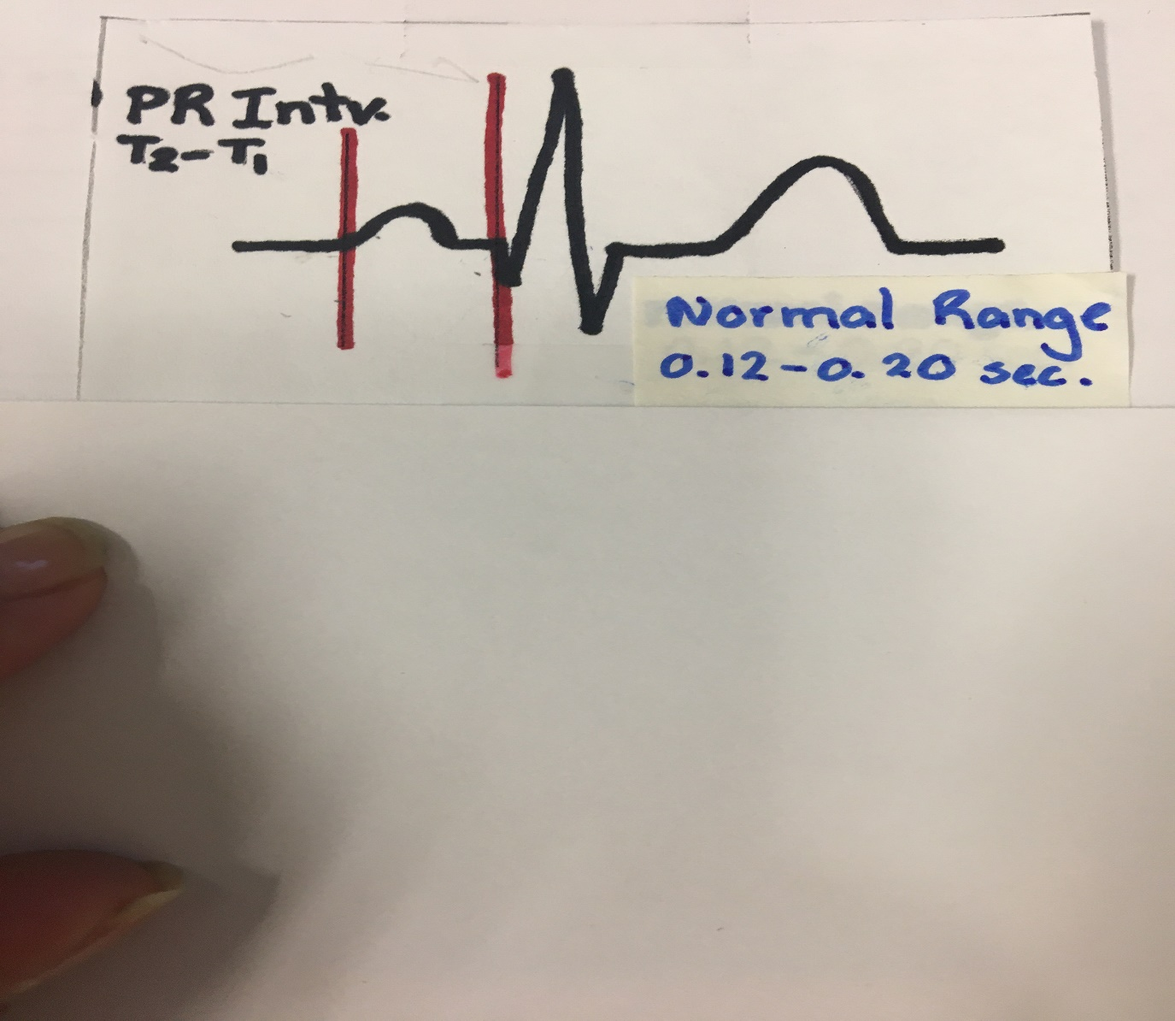

|  |  |  |  |  |
| --- | --- | --- | --- | --- |
| **Lead** | **PR Interval#1** | **PR Interval #2** | **PR Interval #3** | **PR Interval Average** |
| **II** |  |  |  |  |

**QT Interval**

To measure this time interval, place one cursor at the beginning of the QRS complex and the second cursor at end of the T wave. The value for T2-T1 on the ECG channel is the Q-T interval. Measure this time interval for two additional ECG cycles.

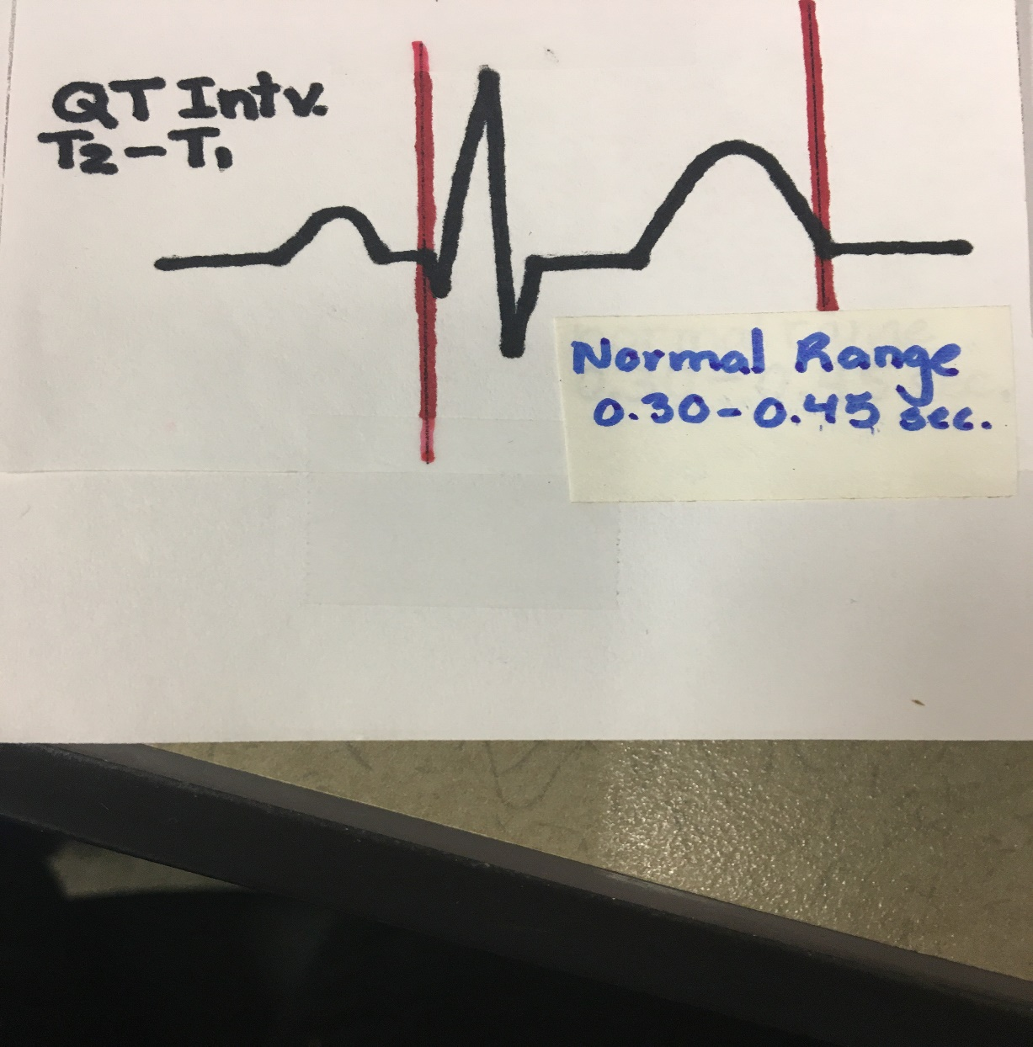

|  |  |  |  |  |
| --- | --- | --- | --- | --- |
| **Lead** | **QT Interval #1** | **QT Interval #2** | **QT Interval #3** | **QT Interval Average** |
| **II** |  |  |  |  |

**QRS Complex**

To measure this time interval, place one cursor at the beginning of Q and the second cursor at the end of S.

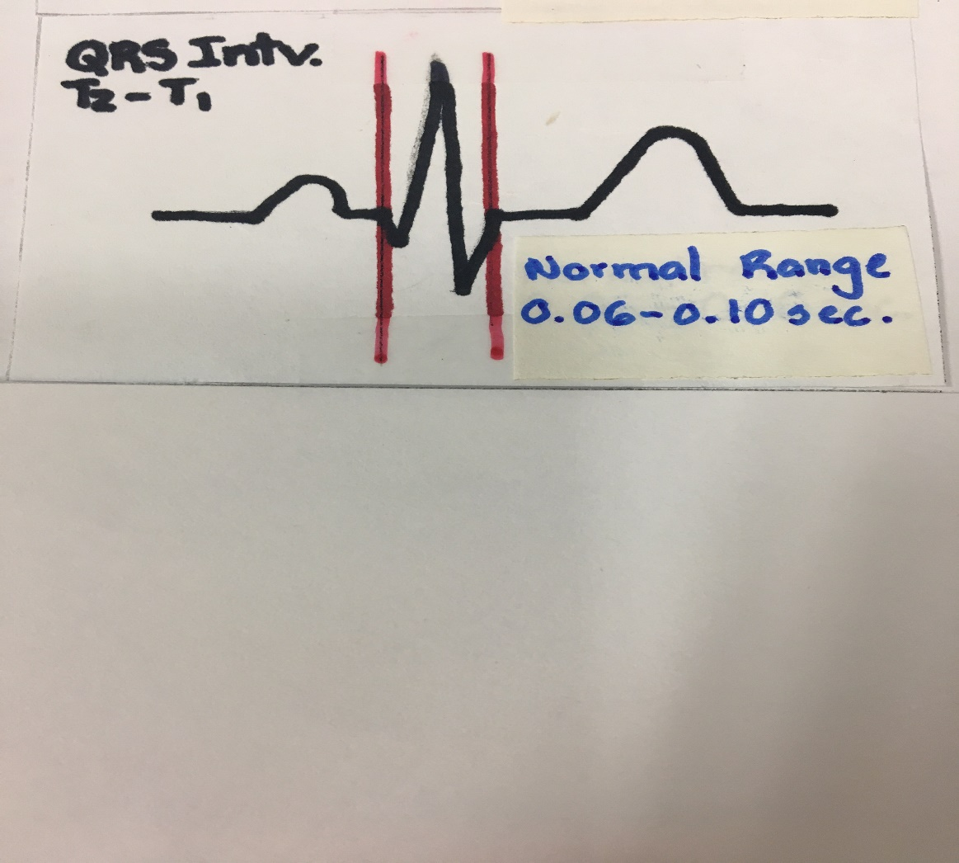

|  |  |  |  |  |
| --- | --- | --- | --- | --- |
| **Lead** | **QRS Complex #1** | **QRS Complex #2** | **QRS Complex #3** | **QRS Interval Average** |
| **II** |  |  |  |  |

**R-R interval**

To measure this time interval, place one cursor on the peak of a R wave and the second cursor on the peak of the adjacent R wave. The value for T2-T1 on the ECG channel is the beat period. Measure the R-R interval for two more pairs of R waves. This value will be used to calculate heart rate.

|  |  |  |  |  |
| --- | --- | --- | --- | --- |
| **Lead** | **R-R interval #1** | **R-R Interval #2** | **R-R Interval #3** | **R-R Interval Average** |
| **II** |  |  |  |  |

**Heart Rate (BPM) = 60________**

**R-R interval**

|  |  |  |  |  |
| --- | --- | --- | --- | --- |
|  | **Heart Rate (adult)** | **PR Interval** | **QT Interval** | **QRS Interval** |
| **Normal Values** | 60 – 100 bpm  Males 64-72bpm  Females 72-80bpm | 0.12 – 0.20 sec | 0.30 – 0.45 sec | 0.06 – 0.10 sec |
| **Your Values** |  |  |  |  |

**POPS PROJECT:**

Please enter the data from the above table that includes PR Interval, QRS Duration, and QT Interval on the Microsoft form.