LAB 1: HOMEOSTASIS, GRAPHING, FALLACIOUS REASONING AND CIRCADIAN RHYTHM

Pre-Lab Reading

Homeostasis
The major unifying principle of physiology is Homeostasis. Homeostasis describes the body’s ability to maintain itself in a steady (but not necessarily constant) state. A steady state occurs when regulated variables, such as blood pressure, pH, glucose concentration, and body temperature, fluctuate about a set point or within a set range. The set point and set range for a variable can be changed by the body as environmental conditions change. For example, the set range for a resting heart rate is very different than the heart rate set range during exercise.

To maintain a regulated variable within the set range (i.e. homeostasis), the body uses negative feedback. When the regulated variable is outside the set range, negative feedback mechanisms respond to reverse the change, returning the regulated variable back toward its set point. Negative feedback mechanisms consist of: (1) sensors, which are often neurons or receptors that monitor the variable; (2) an integrating center (usually the central nervous system or the endocrine glands), which compares the value of the variable to the set range and determines the proper response to maintain or return the variable to homeostasis; and (3) effectors, which are usually muscles or glands that carry out a response which returns the variable to within the set range.

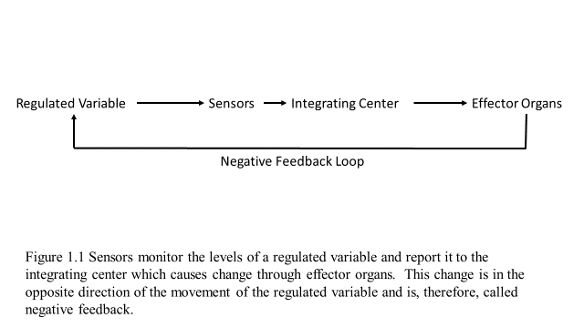

Body temperature is a variable that is maintained in homeostasis by negative feedback mechanisms. As with many examples of negative feedback, the temperature regulation system includes antagonistic effectors. That is, some of the effectors will act to increase the core body temperature while others will act to decrease the core body temperature. The activity of these antagonistic effectors is determined by the integrating center. The hypothalamus contains one of the sensors that monitors body temperature and is also the integrating center. The response to a variation in body temperature could be stimulation of the sweat glands to reduce the temperature (if the body temperature had risen above the current set range) or signaling skeletal muscles to shiver to increase body temperature (if the body temperature had fallen below the current set range). The integrating center will also send messages to the smooth muscles of peripheral blood vessels to either increase blood flow to the skin (allowing for heat dissipation) or decrease the blood flow to the skin (retaining heat within the core of the body). In summary, the response generated by a negative feedback system changes the variable in the opposite direction as the original change that activated the system.

In addition to negative feedback, the body also sometimes uses feed-forward mechanisms to aid in the maintenance of homeostasis. Feed-forward mechanisms allow the body to anticipate change in a variable and to prepare for that change so that it is as small as possible. One example of a feed-forward mechanism is seen in the regulation of blood glucose concentration. When food enters the small intestines, a hormone called GIP (glucose-dependent insulinotropic peptide) is released from the epithelium of the small intestines and travels through the blood to the pancreas where it stimulates the release of insulin in anticipation of rising blood glucose levels since the food will be absorbed shortly. When the blood glucose concentration does rise due to the absorbed food, more insulin is secreted to add to what has already been released from the pancreas (the sensor and integrator), and the body cells (effectors) absorb and store glucose, thus decreasing the blood glucose concentration back to its set point. This second response is negative feedback. Together, negative feedback and feed-forward mechanisms work to maintain the blood glucose concentration in a very narrow range.

A second example of a feed-forward mechanism is observed when one is preparing for an athletic event like a marathon. A marathon runner’s heart rate increases even before she begins to run. This increase is in response to epinephrine that was released from her sympathetic nervous system in anticipation of the race that was to come. Next time you get ready to exercise, think about feedforward mechanisms – do you observe your heart rate increasing? Why or Why not did this happen?

Positive feedback is designed to accelerate or enhance the output created by a stimulus. Unlike negative feedback and feed-forward mechanisms which function to minimize change in a variable, positive feedback mechanisms are designed to push levels further out of normal ranges—that is, to cause a change.

One positive feedback example in the body is the process of blood coagulation. Normally, contact with a damaged blood vessel stimulates platelets to become activated and stick to each other. These initial activated platelets will then secrete chemicals that activate other passing platelets, which then activate still other passing platelets until a platelet plug has been formed, covering the damaged area. This type of positive feedback can also be referred to as an amplification cascade since each step is larger than the previous step. These activated platelets will start yet another amplification cascade by activating a series of enzymes within the plasma that will ultimately produce the active proteins thrombin and fibrin. Once a small amount of thrombin is produced, that thrombin activates still more enzymes to make even more thrombin, creating another positive feedback loop. The thrombin activates the production of fibrin, which forms a mesh, trapping red blood cells to form a clot. The purpose of this process is to cause a change in the body, that is, to stop the flow of blood from a damaged vessel. The process stops when the damage has been repaired and no more blood loss is occurring. Inappropriate activation of these mechanisms can lead to unwanted and harmful blood clotting. For example, platelets can become activated because of the rupture of lipid plaques in the walls of blood vessels or because of very slow blood flow through a vessel.

A second example of positive feedback is the release of oxytocin from the posterior pituitary gland during childbirth. Oxytocin stimulates uterine smooth muscle contraction. The contractions push the baby’s head against the cervix, generating pressure on the cervix. This pressure is detected by sensors which send messages to the hypothalamus about the increased pressure. The hypothalamus then causes the release of more oxytocin. The increased oxytocin level causes increased smooth muscle contraction which results in increased pressure on the cervix. This self-amplifying system will stop when the baby has passed through the cervix during delivery.

In the above situations, the current condition of the body (bleeding or baby in uterus) should not be maintained. Instead, a change was required, and the positive feedback mechanisms ensured that this change occurred quickly. Once the stimulus was removed (damaged vessel wall no longer exposed, baby born), the effectors of the mechanism were turned off. In summary, the response generated by a positive feedback system changes the variable in the same direction as the original change that activated the system. This system will not stop until the original stimulus is removed and/or a second system interrupts it.

Positive feedback can also be harmful. One example of this is circulatory shock, a condition in which blood flow to the tissues is insufficient due to falling blood pressure. There are several causes of circulatory shock, including hypovolemic shock due to low blood volume, anaphylactic shock from a severe allergic reaction, and cardiogenic shock usually resulting from a heart attack. Initially, the body responds to low blood pressure through negative feedback mechanisms in order to raise the blood pressure. If these actions fail, decompensated shock develops and life-threatening positive feedback loops occur. One such positive feedback loop develops when poor blood flow to the heart results in the death of cardiac muscle cells, thus further weakening the pumping action of the heart. As the pumping efficiency of the heart decreases, blood pressure continues to fall, and blood perfusion throughout the body – including the heart – decreases. The reduction in blood supply to the heart muscle results in more cardiac cells dying, which further weakens the heart and results in even less blood flow to the tissues.

Graphing
Scientists collect data in order to explore physical phenomena. One of the most powerful ways to organize that data is in a graphical way. Graphs are used to summarize and visually display data. The best graphs are simple and show the patterns in the data with a single glance. There are many different types of graphs, but we will focus on line graphs and scatter plots, which you will be creating in the labs this week and the following week. The following steps will help you create an easily interpretable graph.

Before ever creating a graph, really think about the data that has been collected. What variable(s) were measured and what variables did not change? The independent variable is the experimental condition controlled by the scientist and is plotted on the x-axis (horizontal). The dependent variable is the one the scientist is trying to learn about. The dependent variable is plotted on the y-axis (vertical). A properly constructed graph will provide a visualization of the relationship between these two variables. For example, if you are interested in determining how a new drug affects a person’s heart rate, you could give your subjects different amounts of the drug (independent variable) and measure how heart rate changes (dependent variable).

Next, determine the range of your data to decide how best to distribute those data to use as much of the graphing area as possible. Choose appropriate unit intervals so that you can easily plot your data. Always provide an appropriate label (including the units of measurement) for each of the axes. The graph also must have a descriptive title and the entire graph will then usually have a figure number and a descriptor to explain the data plotted on the graph.

After you’ve clearly plotted the data on the correct axis, analyze your graph for relationships between the two variables. If the dependent variable increases as the independent variable increases, there is a positive correlation between them. If the dependent variable increases while the independent variable decreases, there is a negative correlation between them. There might be a periodic variation between the variables such as a sine wave. The pattern of change could be either linear or exponential. The relationship may reach a point of saturation. There may be other variables that might disrupt or alter the pattern that you currently see. These are the types of observations that lead one to understand the phenomenon that is being studied in the experiment represented by the graph.

Recognizing and Avoiding Fallacious Reasoning
Scientists use the scientific to maintain a logical flow of inquiry. As scientists collect data to test hypotheses they must be sure to use correct logic and reason. A fallacy is a mistake in reasoning. When one draws a conclusion that is not supported by the available evidence, he has used fallacious reasoning. A simple but obvious example of a fallacy is demonstrated by the following statements. “Turtles are animals. All mammals are animals. Therefore, turtles are mammals.” The first two statements are true; however, the third statement is a fallacy because it drew a conclusion that was not supported by the available evidence. Figure 1.2 is a humorous example of fallacious reasoning. Perhaps you can recognize that this type of reasoning is often used in advertising and other forms of “propaganda” media. If subtle, fallacies can produce very convincing arguments; thus, one must always be wary of them.

Fallacious reasoning should be suspected if an argument or advertisement makes extraordinary claims that are supported by anecdotal evidence. If correct, an extraordinary claim forces one to re-evaluate several already accepted explanations for related events. Thus, these claims, if correct, would be very revolutionary; they would not follow the rule of Occam’s razor (discussed later). Revolutionary advances in the body of scientific knowledge do occur; however, their occurrences are very rare. One should evaluate such claims by performing well controlled experiments with testable predictions and statistical analyses.

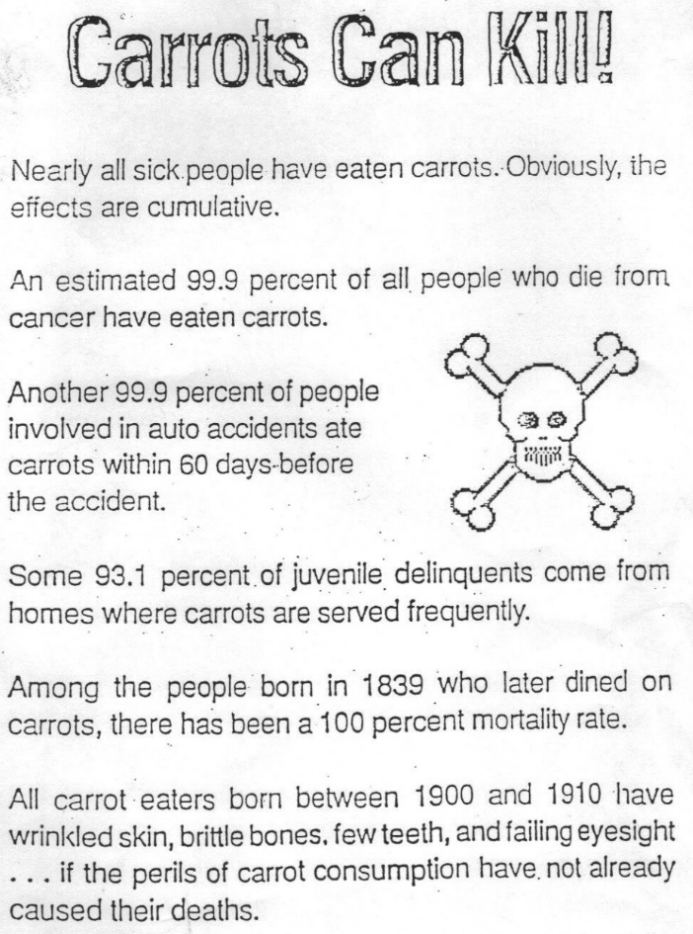

Figure 1.2:
Every fact on this figure is true, so what makes this fallacious?

Anecdotal evidence includes testimonials or stories from individuals about a certain event. The problem with this type of evidence is that it may be neither falsifiable nor verifiable under neutral conditions. For example, many individuals have lost weight while on the hCG diet. When one hears such success stories, he/she may accept this anecdotal evidence and conclude that the hCG injections are instrumental in allowing the weight loss. However, one can find no literature reports of a controlled experiment showing that the hormone hCG causes one to lose weight. The protocol for the hCG diet requires that the participant limits his/her daily caloric intake to 500 Calories. It is much more likely that this low caloric intake is causing the weight loss rather than the hCG injections.

One form of a fallacy is to attribute causation of one variable to change in a second variable when, in fact, the two variables are only correlated to each other. As stated above, a graph allows one to quickly visualize the relationships between two measured variables. Positive and negative correlations are easily seen in a graph. However, a graph does NOT allow one to conclude that one variable CAUSES a change in the second variable.

For example, a graph may show a positive correlation between blood pressure and blood cholesterol concentration. Does the high blood pressure CAUSE the increased cholesterol concentration? Does the high cholesterol CAUSE the high blood pressure? Or, is there some underlying condition that causes both of these variables to change in the same direction and thus be positively correlated?

Here is another example of the similarities and differences between correlation and causation. In a study published in the scientific journal, Nature, researchers discovered that children who sleep with the light on are much more likely to become myopic (nearsighted) later in life. What was uncertain was whether leaving the light on was causing the later development of myopia or was simply correlated with the later development of myopia. A second study investigated this finding further and did not find a link between infants sleeping with the light on and the development of myopia. Instead the researchers found a strong association between parental myopia and the development of child myopia. They also noted that myopic parents more frequently left a light on in their children's bedroom than did non-myopic parents. Thus, the lights and myopia in children were positively correlated; however, the causative factor was probably genetic. One of the most common errors we find in the press is the confusion between correlation and causation in scientific and health-related studies. Correlation is not causation, but it can be a hint to look further.
Check out this website that really illustrates how correlation and causation can get wrongly confused:

http://www.tylervigen.com/spurious-correlations

How, then, does one ever establish causality? The most effective way of doing this is through a controlled study. In a controlled study, two groups of people who are comparable in almost every way are randomly assigned to one of two different sets of experiences (such as one group watching soap operas and the other game shows), and the outcome (success in college algebra) is compared. If the two groups have substantially different outcomes, then the different experiences may have caused the different outcome. This example is called a randomized controlled experiment because the subjects were randomly placed into one of the two groups. Long-term randomized experiments are difficult to perform on humans for a variety of reasons, including ethical considerations. Two other types of controlled experiments are often used instead. The evidence collected from these experiments is not considered to be as strong as that from a randomized experiment. In a prospective controlled experiment, the two groups are divided by the type of television show the individual has watched. Individuals that have watched only soap operas are placed in one group while individuals that have watched only game shows are placed in the other group. Once the groups are formed, the desired outcome (success in college algebra) is compared between the two groups. In a retrospective controlled experiment, the two groups are formed by a measured difference in the outcome. One group consists of individuals that received a C or better in college algebra while the other group consists of individuals that received a D or E in college algebra. Once the two groups are formed, they are evaluated to see if there is a statistically significant difference in the type of television show watched by the individuals in the two groups.

Even in a very well designed experiment, one must be wary of evaluator bias, causative variables that have not been considered, and other confounding factors. The only way to become convinced of causality is through several independently performed experiments, all leading to the same conclusion. Even then, something may have been missed; thus, most scientists do not use the words “facts” or “proof”. Whichever type of experiment is used, there are two rules that should be followed when developing a hypothesis and designing an experiment. The first rule is known as Occam’s razor, which says that one should always begin with the simplest explanation for any situation (i.e. “Keep it simple, stupid!”). The second rule is that any hypothesis that you have developed should lead to testable predictions. That is, the predictions must be stated such that we can clearly measure whether that prediction has been fulfilled or not. The following are some examples of testable and non-testable hypotheses.
Non-testable:
1. There is a type of particle that is currently too small to be seen or detected in the lab. If you get the flu, your flu symptoms are worse if you have a large concentration of those particles in your home.
2. You are more likely to get a cold if the Greek goddess Athena is angry at you.
Testable:
1. If you have the flu, your flu symptoms will be worse if you drink more than 30 ounces of water per day.
Non-testable in the year 1600, but testable in the year 1953:
1. A molecule that has a double helical shape and is too small to be seen with the naked eye is the hereditary molecule of humans.

How to identify particular types of fallacious reasoning:
Unfortunately, we are surrounded by examples of fallacious reasoning. Sometimes the source of such fallacies are unaware that they are doing this and other times fallacious reasoning tools are knowingly employed to sway peoples’ opinions. In order to be an educated person, you will need to gain the skills of logic and reason as well as the ability to identify and avoid the traps of fallacious reasoning.

Remember, this is a science lab so we’ll be expecting you to think and act like a scientist. As you are engaging in laboratory experiments and analyzing and discussing your data, make sure to use reason and logic in your work. Do not use fallacious reasoning!

Circadian Rhythm
Now let’s delve deeper into homeostasis by learning about regulated variables that change with light/dark cycles. Circadian rhythms are self-sustaining regular changes in mental and physical characteristics that occur in the course of a 24-25 hour day (circadian is Latin for "around a day"). Humans show circadian rhythms over a wide variety of cellular, physiological, and psychological processes. Researchers have identified circadian rhythms in such variables as heart rate, blood pressure, respiration, and endocrine activity. These physiological rhythms often parallel psychological and behavioral processes, including sensory, emotional, cognitive, and motor functions. Figure 1.3 indicates some of the variables that change over the course of a 24 hour day.

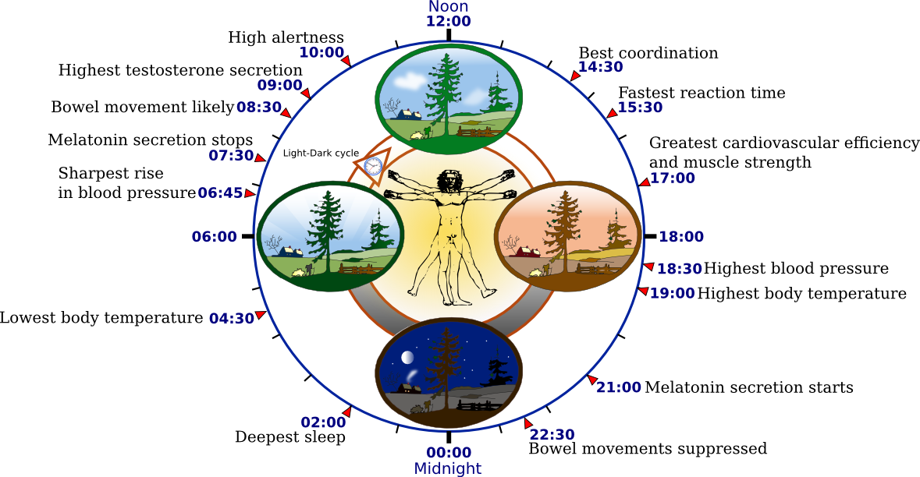

Figure 1.3. The condition of several variables within the body over a 24 hour period. (from web images)

The hypothalamus receives input about external light levels and day length in order to coordinate the circadian rhythms to external cues. Even without any external cues such as alternating light and dark periods, the cycles persist, although they tend to drift away from a 24 hour to a 26 hour cycle. The suprachiasmatic nucleus (SCN) of the hypothalamus seems to be the site in the central nervous system that establishes the circadian rhythms. The pineal gland, which is also located within the brain, secretes a hormone called melatonin. Recent research suggests that melatonin is important in regulating seasonal as well as circadian rhythms. Melatonin levels rise in the evening, causing drowsiness, and fall during the day. Figure 1.4 shows that when light cues are removed, the length of the “day” increases slightly for the secretion of the hormone cortisol. This demonstrates that cortisol is a true circadian rhythm, and that the light simply modifies this rhythm.

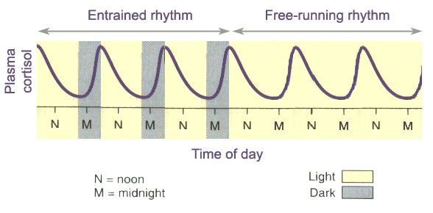
You will be assigned to recorded and tracked your sleep/wake cycles to gain some insight about your own circadian rhythms.
Figure 1.4: Plasma Cortisol levels during repetitive light/dark cycles and during continuous light. (from web images)

