Lab 9: ELISA and Blood Typing

Pre-Lab Reading
Much of this overview has been summarized from the textbook Principles of Human Physiology by Stanfield. If you would like to gain further understanding of this material, please refer to your text. Information and excellent study questions about the immune system can be found at http://www.biology.arizona.edu/immunology/immunology.html.

Overview of the Immune System
The body has developed very efficient mechanisms to protect itself from foreign objects (bacteria, viruses, toxins) and dangerous self materials (mutated, virus-infected, or cancerous cells, and unwanted cellular debris). The cells designed to defend our bodies are the leukocytes (white blood cells), and collectively, the defense mechanisms are called the immune system. The immune system first reacts to stimuli using nonspecific defenses and then ultimately uses a specific defense system. The nonspecific defense system will attack pathogens (disease causing agents) at any site where those pathogens try to enter the body. Key cells of this nonspecific defense include the granulocytes (neutrophils, eosinophils, basophils), the monocytes/ macrophages, and the NK (natural killer) cells.
The specific defense system mainly operates within the lymphoid tissues—the spleen, lymph nodes, tonsils, Peyer’s patches of the small intestine, and the appendix. It is within these lymphoid tissues that the B and T lymphocytes lie in wait to attack specific pathogens. Once activated, these cells and their products can circulate throughout the lymphatic and circulatory system to specific targets.
Nonspecific defense occurs through four processes:
- physical barriers prevent entry
- inflammation prevents spread and begins to destroy the pathogen
- NK (natural killer) cells destroy virus-infected or cancerous cells
- complement proteins bind to generalized bacterial membrane carbohydrates.

The above processes are carried out by:
- the skin and mucous membranes
- chemicals that induce inflammation (histamines, cytokines, and others) and fever (pyrogens); the phagocytic cells (neutrophils, monocytes and macrophages, and to a lesser extent, eosinophils)
- NK cells which recognize a decrease in the class I MHC proteins on the surface of virus- infected or cancerous cells
- chemicals known as complement proteins, which help destroy bacteria, and interferons that prevent viral replication.

The nonspecific defense system does not need to identify the specific pathogen before working to destroy it. Because there is no identification process, the nonspecific defense system will not remember a pathogen the second or third time the body is exposed to it, and hence the response does not become stronger, faster, or more efficient with experience. On the other hand, this mechanism is already very fast because the system does not need to spend time identifying the pathogen. The four processes of nonspecific defense are functional from birth; therefore, nonspecific defense is sometimes referred to as innate immunity.
The specific defense mechanism occurs largely through the efforts of the B and the T lymphocytes. The activation of these lymphocytes is assisted by activated macrophages and by chemicals produced during the nonspecific immune response. Thus, macrophages and these chemicals form a bridge between the nonspecific and the specific defense mechanisms. As the name implies, the specific defense mechanisms are designed to destroy cells or particles that have been “identified”. These mechanisms will also remember the identified pathogens and will produce a much faster and stronger response against them the next time that pathogen is encountered throughout an individual’s life. Because of this enhanced ability to fight off a pathogen after originally being exposed to it, the specific immune response is referred to as acquired immunity.
The four characteristics of specific (acquired) immunity are: (1) specificity, (2) diversity, (3) memory, and (4) self-tolerance. Each of these characteristics is described below.

The Activation of Specific Immunity by Antigens Demonstrates Both Specificity and Diversity

The specificity of the immune response involves the reaction of antigens to receptors on the membranes of B lymphocytes and T lymphocytes. These receptors are called membrane antibodies on the B lymphocytes and T cell receptors on the T lymphocytes. Each cell displays specific receptors that can recognize usually only one type of antigen. This specific antigen-receptor relationship is very similar to the ligand-receptor relationship that you learned about in cellular communication systems or the substrate-active site relationship of enzymes. An antigen is any molecule (usually a protein or polysaccharide) that can activate the immune system. This activation occurs because the antigen is recognized by the membrane antibody on a B cell or the T cell receptor on a T cell. Here is the amazing part: due to some very interesting genetic expression, the human body makes millions of different receptor shapes—each being made by an individual lymphocyte and its offspring or clones. Thus, the body has within it a B cell and a T cell that will recognize any antigen the body might come across during life! This arsenal of different receptors is the diversity of specific immunity. When a specific antigen-receptor interaction occurs, the lymphocyte (B or T) is activated to produce many clones (copies) of itself, each possessing the same receptor as the original cell. This process is called clonal expansion. These clones then differentiate (become specialized for various functions) into effector cells. For B lymphocytes, the effector cells are plasma cells and memory cells. For T lymphocytes, the effector cells are cytotoxic T cells, helper T cells, regulatory (or suppressor) T cells, and memory cells.

Activated B Lymphoctyes Perform Humoral Immunity
When a B lymphocyte is activated by a specific antigen binding to its receptors, the cell proliferates and differentiates into plasma cells, which secrete into the bloodstream thousands of copies of antibodies (also called immunoglobulins) that match the original receptor (remember that the receptors on B lymphocytes are called membrane antibodies). Each secreted antibody possesses the specific shape that binds to the antigen that activated its original B lymphocyte. Because these antibodies are found in the plasma and the blood was historically called a “humor”, the production of antibodies by plasma cells is called humoral immunity. These antibodies will now bind to and mark the specific antigen for destruction by phagocytosis and other methods.
The second effector cell produced from an activated B lymphocyte is the memory cell. The memory cells will reside in the lymphoid tissue until this particular antigen invades the body again.
At that time, the memory cells can quickly undergo clonal expansion and differentiate into plasma cells to begin antibody production. This secondary response only requires 2-3 days, whereas the primary response required 10-14 days.

Activated T Lymphocytes Perform Cell-Mediated Immunity AND Regulate the Rest of the Immune System
The effector cells produced by clonal expansion and differentiation of a T cell are cytotoxic T cells, helper T cells, regulatory (suppressor) T cells, and memory cells. The memory cells function the same as described above; they wait to encounter the antigen a second time and thus allow for a rapid secondary immune response. The activated cytotoxic T cells will bind to antigens found on the surface of abnormal cells, including foreign cells (such as from a tissue transplant), cancerous cells, or virus-infected cells. This reaction of the T cell receptor to the antigen is quite complex and involves two other important proteins: the CD8 protein found on the cytotoxic T cell and the class I MHC protein found on the body cell. When the antigen-receptor binding is correctly accomplished, the cytotoxic T cell will kill the targeted cell by releasing chemicals, which poke holes in the cell membrane. Because cytotoxic T cells must come in direct contact with the cells they destroy, this type of defense mechanism is known as cell-mediated immunity. The complex interaction between the CD8 protein and the class I MHC protein (found on all nucleated body cells) is necessary to prevent the immune system from destroying normal body cells. This ability to recognize and not damage normal body cells is called self-tolerance. Unfortunately, this ability sometimes is partially lost, resulting in an autoimmune disease.

The role of helper T cells and regulatory (suppressor) T cells is quite different than that of plasma cells or cytotoxic T cells. These cells are more regulatory in nature, with the helper T cells working to activate various mechanisms of the immune system and the regulatory
(suppressor) T cells working to turn down or turn off various mechanisms of the immune system. The various roles of the regulatory (suppressor) T cells are still being determined. Errors in this regulation may also be involved in the development of autoimmune diseases.
Helper T cells will bind to macrophages and B lymphocytes through an antigen-receptor complex that also requires two other proteins: a class II MHC protein on a macrophage or activated B cell and a CD4 protein found on the helper T cell. If the helper T cell recognizes the antigen, the helper T cell will be activated. The activated helper T cell will now release more signaling molecules (interleukins) to stimulate the B cell that it is in contact with or the cytotoxic T cell that recognizes that specific antigen as well. This activation of immune cells by the helper T cells is absolutely necessary to produce an effective response against a pathogen; thus, if the helper T cells are not functioning properly, the entire specific immune system is ineffective. For example, without the interleukin released from activated helper T cells, activated B or T lymphocytes cannot differentiate into memory cells.

How HIV Affects the Immune System
One of the most devastating diseases to affect the human population has been acquired immunodeficiency syndrome (AIDS), which is caused by a retrovirus called human immunodeficiency virus (HIV). HIV is an extremely successful virus because it attacks and resides in the very cells that are designed to activate the immune system—the helper T cells. The only aspect of the structure and replication mechanisms of this viral particle that will be mentioned in this discussion is the protein called gp120. This protein is on the surface of the virus, and it specifically binds to the CD4 protein of the helper T cells. When the viral gp120 binds to the CD4 protein, HIV is taken into the helper T cell by receptor-mediated endocytosis, infecting the cell. The virus will remain quiet inside this helper T cell until the cell is activated by a normal antigen-receptor interaction. At that point, HIV becomes active and takes control of the helper T cell. The cell is unable to do its normal functions, and instead it becomes a virus factory. The effectiveness of the specific immune system decreases dramatically and the symptoms of AIDS occur as more helper T cells are invaded by HIV
Because HIV can remain quiescent and hide inside the helper T cells, it was difficult to determine if a person had been exposed to this virus. So instead of trying to detect the virus directly, researchers decided to search for the presence of antibodies against HIV. If a person has been exposed to HIV, his immune system was activated and anti-HIV antibodies will be present in the blood. A technique called ELISA (enzyme-linked immunosorbent assay) is used to detect the presence of these antibodies within a person’s bloodstream. The ELISA was the standard detection method for HIV infection for many years and is still often used. Today, HIV infection can also be detected by a PCR (polymerase chain reaction which increases the copies of HIV DNA in order to more easily detect it) method. Further details of the ELISA are discussed below.

Structural Details of Antibodies

If an antigen is introduced to an individual, plasma cells will produce and release antibodies into the bloodstream. The specific site on an antigen that is recognized by an antibody is known as an epitope. An antigen may have several separate epitopes, and each epitope will stimulate the production of a different antibody. If we collect serum from this individual who has produced several antibodies against the introduced antigen, we are collecting antiserum. These antisera (antibodies) can be used therapeutically by giving them to patients to help fight infections and even to neutralize snake venom.

Antibodies are multimeric proteins that consist of two heavy chains and two light chains; each chain contains a variable region and a constant region. The variable region, which is unique for each different antibody, binds to a specific epitope on a specific antigen and forms the antigen-binding portion of the antibody. The variable regions on circulating antibodies are the same as those on the membrane antibody of the plasma cell that secreted that antibody. The constant region of the chains is identical for all antibodies in a particular class and forms the effector portion of the molecule. This effector portion of the antibody will allow the specific antigen that was bound by the variable region to be destroyed by a variety of mechanisms.

Immunoassays
Immunoassays are designed from our understanding of antibody-antigen interactions. Many different immunoassays, such as ELISAs, radioimmunoassay (RIA), and Western blots, have been developed to identify various antigens or antibodies in a patient’s blood or in other samples. We will only discuss how ELISAs work since that is what we will be using to detect HIV infection in this lab.

ELISA (Enzyme-Linked Immunosorbent Assay)
An ELISA uses an antibody that has been modified by conjugating (linking) an enzyme to the antibody. The enzyme that is linked to the antibody is capable of catalyzing the conversion of a colorless substrate to a colored product. The intensity of the color that develops is directly proportional to the amount of enzyme-linked antibody present. The intensity of the developed color can be visually determined or it can be quantified using a spectrophotometer. One of the enzymes commonly used is horseradish peroxidase, which can act on substrates such as benzidine or alphanaphthol to produce a blue or yellow product. A good description and demonstration of an ELISA can be found at http://www.biology.arizona.edu/immunology/activities/elisa/main.html. Versions of the ELISA include a sandwich assay, an indirect assay, and a competitive assay. Each of these versions is described on the slccphysiology website.

Determination of A, B, O and Rh (D) Blood Types
Classical A, B, O, and Rh (D) blood typing will be used to introduce the idea of antibody-antigen interactions. Antigen-antibody interactions are a very important component of the immune system. The identification of an individual's blood type is important, because, if during a blood transfusion the donor's blood were of a different type than the recipient's, the resulting antigen-antibody reaction may be considerably detrimental if not lethal. Thus, blood is always typed and cross-matched before being given to a patient.
Antigens form the basis of the immune response against viruses, bacteria, and other foreign cells. Antigens are defined as any chemicals that are able to cause the production of antibodies. Interestingly, the body recognizes the chemicals (usually proteins or glycoproteins) on its own cells as self-antigens and normally will not produce antibodies against them. The process within the immune system of recognizing self-antigens is known as the development of self-tolerance. When microbes such as viruses and bacteria enter the body, certain white blood cells recognize the microbes' antigens as non-self and produce protein antibodies that are specific for that particular type of non-self antigen. The result is an antigen-antibody reaction, which hopefully neutralizes the invading microbes.
The membranes of all cells possess marker molecules which identify them as specific cell types within a specific individual. These markers can act as antigens in certain situations. Cells may characteristically have antigens that are tissue specific (e.g.- liver, muscle, etc.), species specific (e.g.-human, canine, turtle, etc.) and individual specific (e.g.-mine, yours, hers, his). Only the cells of identical twins have exactly the same membrane antigens of all types. In the early 1900's Karl Landsteiner identified the A and B glycolipid antigens, which are found in the membranes of red blood cells (RBCs). The Rh (D) factor, a protein in the RBC membrane, was discovered in the 1940s. These particular antigens on RBCs have since become known as agglutinogens. The reason for this name will become apparent.
The tests to determine A, B, O and Rh blood types are based on antigen- antibody reactions. The data in Tables 9.1 indicate that individuals of blood type A have RBCs with A agglutinogens and their plasma contains anti-B antibodies. These anti-B antibodies will specifically react with B agglutinogens and produce agglutination (clumping) of type B red blood cells if those cells are ever introduced to this person. Notice that the person with type A blood does not make anti-A antibodies because her immune system recognized these as self-antigens and developed tolerance to them. Conversely, the plasma of an individual with blood type B (B agglutinogens) contains anti-A antibodies but no anti-B antibodies. A person with blood type AB contains neither anti-A or anti-B antibodies in the plasma; however, a person with blood type O has both anti-A and anti-B antibodies in the plasma.

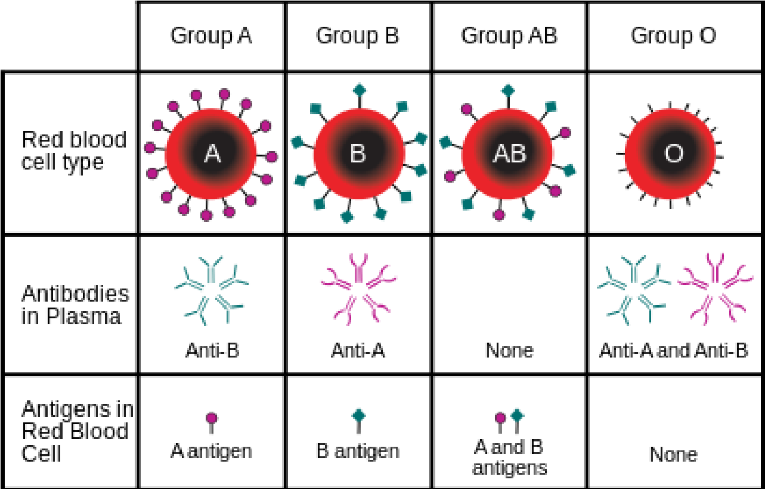

Table 9.1 ABO blood group antigens present on RBCs and antibodies present in the serum. Taken from Wikipedia.
Remember, the agglutinogens (antigens) are on the membrane of the red blood cells, the antibodies are in the plasma. Oddly enough, we have all produced the antibodies against the appropriate non-self A and/or B antigens even before we have been exposed to a blood type different from our own. The most widely accepted explanation for this is that there are antigens on bacteria that are very similar to the A and B glycolipids and that these bacterial antigens cause the initial production of the anti-A and anti-B antibodies. Because these antibodies are formed without a known initial exposure to the foreign blood type, they are sometimes referred to as natural antibodies.
Agglutination is a reaction between incompatible RBC agglutinogens and plasma antibodies resulting in visible clumping, or sticking together of the RBCs. If a recipient with blood type A were mistakenly transfused with blood from a donor with blood type B, the antibodies of the recipient's blood (Anti-B) would react with the donor's RBC B agglutinogens to produce an agglutination reaction:
B agglutinogen + anti-B antibody = agglutination reaction (donor RBCs) (recipient)
The Rh factor, or D factor, is a separate agglutinogen from the A and B agglutinogens. That is, it is controlled by and inherited as an independent gene. If present, the Rh factor (a protein found in the RBC membrane) establishes the RBCs as Rh+, and if absent the RBCs are referred to as Rh-. The Rh factor was named after the Rhesus monkey where it was first discovered. While the anti-A and anti-B antibodies are "natural antibodies", meaning that they appear in an individual's plasma even before that individual has been exposed to the actual agglutinogen, the anti-Rh antibodies only appear in the serum of an Rh- person after he/she has been exposed to the Rh antigen in Rh+ blood.

REFERENCES
Much of this overview has been summarized from the textbook Principles of Human Physiology by Stanfield.

