Lab 7: ECG

Pre-Lab Reading
Electrical Conduction in the Heart
We often think of the heart as a single muscular pump. The reality is that the heart is actually two conjoined pumps that work together to circulate blood through the entire body. One pump (the right side of the heart) is involved in pulmonary circulation where blood is pumped to the lungs and then back to the left side of the heart. The other pump (the left side of the heart) is responsible for systemic circulation where blood is pumped throughout the rest of the body and then back to the right side of the heart. Both processes involve the sequential contractions of their respective atria and ventricles, which is synchronized by the heart’s electrical conduction system.
It should be noted here that cardiac myocytes (muscle cells) of the atria and ventricles form two networks known as the atrial syncytium and the ventricular syncytium. Each syncytium is a network of cardiac muscle cells connected by gap junctions located in the intercalated discs, allowing coordination of the contraction of the heart’s chambers. Electrical resistance through the gap junctions is very low, which permits the free diffusion of ions. As a result, action potentials (large, rapid changes in the membrane potential in which the inside of the cell becomes positive relative to the outside) propagate readily from one myocyte to the next. In terms of cardiac activity, this means that when one cell contracts, they all contract.
The electrical impulses generated by the heart’s conduction system begin in the sinoatrial node (SA node), which is located in the upper wall of right atrium (Figure 1) near the entrance of the superior vena cava. Since the heart’s electrical activity begins with the SA node, it is known as the pacemaker of the heart. The SA node is actually a group of specialized cardiac myocytes that can spontaneously depolarize (the membrane potential becomes more positive than it is at rest). The depolarization of the SA node is followed by depolarization of the atria, which then causes contraction of the atrial musculature. The right atrium contracts slightly before the left atrium since that is where depolarization begins.
Electrical waves from the SA node are also conducted by internodal pathways (made up of specialized myocardial cells called conduction fibers) to the atrioventricular node (AV node) located at the base of the right atrium near the opening of the coronary sinus and the tricuspid valve. The AV node transmits action potentials slower, resulting in a 0.1 second delay in the transmission of the electrical current, which delays its arrival at the ventricles. The purpose of this AV nodal delay is to ensure that atrial contraction occurs before the ventricles are stimulated to contract. After leaving the AV node, the electrical current travels through the interventricular septum via conduction fibers called the bundle of His. From here, the action potentials are propagated through the right and left bundle branches and then pass from the apex of the heart up the Purkinje fibers in the lateral walls of the ventricles. As the action potentials spread through the ventricles, contraction of the ventricular muscle tissue occurs.

Cardiac Action Potential
The term “cardiac action potential” refers to a series of changes in the voltage of a cardiac contractile cell over a brief period of time. These changes include depolarization, a plateau period, and repolarization. The membrane potential is a difference in voltage or electrical potential across the cell membrane. There are more anions (negatively charged ions) than cations (positively charged ions) inside the cell, while there are more cations than anions in the extracellular fluid. The membrane potential is always given in terms of voltage inside the cell relative to voltage outside the cell. Thus, for many cells at rest (not sending or receiving electrical signals), the resting membrane potential is -70 mV, indicating that the inside of the cell is 70 mV more negative compared to the outside.
Cations and anions diffuse into and out of cells through specific ion channel proteins. Some of these ion channels are voltage-gated channels. Voltage-gated channels are normally closed (do not allow passage of ions) but will be triggered to open by sufficient changes in the membrane potential of a cell. If a cation-specific voltage-gated channel opens, that cation will normally diffuse into the cell, resulting in a voltage decrease in the membrane potential. This voltage decrease is called depolarization. In other words, during depolarization, an influx of positive ions causes the membrane potential to become less negative and eventually positive.
The depolarization phase of a cardiac muscle action potential begins when voltage-gated sodium ion channel proteins (Na⁺ channels) are stimulated to open, allowing Na⁺ ions to diffuse into the cell (Figure 2). An action potential is a self-regenerating wave of electrochemical activity that allows excitable cells, such as cardiac cells or neurons, to carry an electrical signal over a distance. Depolarization of one cell stimulates the opening of Na⁺ channels in adjacent cells, resulting in a depolarization wave front that propagates cell by cell throughout the heart. The speed of depolarization of a given cell determines how quickly the next cell will depolarize.
Once depolarization is completed, the cell begins to repolarize (the original membrane potential is restored). It is important to realize that the cell cannot depolarize again until repolarization occurs. During the repolarization process, the cell is refractory, which means that it cannot respond to a new stimulus. The plateau stage also occurs during repolarization. This is where the repolarization rate slows down as Ca²⁺ ions diffuse into the cell and K⁺ ions move out. The plateau stage lasts about 0.20 seconds. The Ca²⁺ ions enter the cell and prevent the cell from repolarizing too quickly; thus, extending the refractory period. A long refractory period is important to allow the cardiac muscle cells to fully contract, pump the blood out, and relax before being stimulated to contract again. Cardiac muscle cells will be able to respond to a new stimulus once repolarization is finished. The period following repolarization and before the next depolarization is the quiescent phase. During this period, there is no ion exchange across the plasma membrane in most cardiac cells. The membrane potential during this time is referred to as the resting potential.
At some point, a leakage of ions across the plasma membrane will occur in the SA node cells. This will result in a gradual increase in the membrane potential. When the membrane potential reaches the threshold voltage, depolarization will begin again and a new action potential occurs. The ability of the heart to generate its own action potentials that trigger contractions on a periodic basis is called autorhythmicity. Although the heart has autorhythmicity, heart rate is regulated by the nervous and endocrine systems.

Basic Electrocardiographic Principles and Concepts
Electrocardiography is the process of producing an electrocardiogram (ECG or EKG) with a device called an electrocardiograph. An ECG is a graphic record of the electrical activity of the heart at a given time. The electrical waves that cause the heart muscle to contract pass through the body and can be measured at electrodes attached to the skin. These electrodes are attached on different sides of the heart to measure the activity of different parts of the heart muscle. Note that the electrodes can be positive or negative. The ECG output indicates the overall rhythm of the heart as well as problems in different parts of the heart muscle. It is often considered the best way to detect and diagnose abnormal rhythms of the heart, or in some cases to identify damaged areas of the heart muscle.

Deflection and the Isoelectric Line
As electrical waves move around the heart, they are recorded as a series of deflections (movement of electrical waves from one point to another). This electrical movement produces differences in electrical potential between depolarized and polarized tissue. Changes in this electrical activity are often measured in reference to the isoelectric line or baseline. The isoelectric line represents the quiescent phase that is between repolarization and the next depolarization when no electrical activity is occurring.

ECG Waves
The ECG for one normal complete cardiac cycle (heartbeat) consists of a set of deflections referred to as the P wave, the QRS complex, and the T wave. The isoelectric line (baseline) represents the interval between the end of one heartbeat and the start of the next.

P Wave | Atrial depolarization as electrical activity moves from the SA node towards the AV node and spreads from the right atrium to the left atrium. This occurs just prior to atrial contraction. It lasts about 0.08 to 0.10 seconds.
QRS Complex | This is composed of the Q, R, and S waves that occur together as a result of ventricular depolarization. In fact, each of these three waves actually represents a different stage of depolarization of the ventricles. On the ECG, the QRS complex appears larger than the P wave. One reason for this is that the ventricles contain more muscle mass than the atria. The QRS complex occurs prior to contraction of the ventricles. Normally, the duration of the QRS complex is 0.06 to 0.10 seconds. A duration that is greater than 1 second may be an indication of an impairment of electrical conduction through the ventricles.
T Wave | Repolarization of the ventricles. In terms of the cardiac cycle, it indicates the relaxation of the ventricles after contraction.
**It should be noted that the ECG does not show a wave corresponding to atrial repolarization. This is because it occurs at the same time as ventricular depolarization and is completely hidden by the QRS complex.

Electrocardiographic Leads
The word lead is used here to refer to a combination of electrodes that form an imaginary line in the body along which the electrical signals are measured. For our purposes, the wires that connect the electrodes to the computer (which is serving as our electrocardiograph) are connections and not leads.
Electrocardiographic leads are bipolar, which means they have a negative and a positive terminal. This allows them to detect changes in the electric potential between these two points. For this reason, each lead should be considered as a graphical representation of the electrical potential between its two terminals.
There are three standard leads:
Lead I | This is between the right arm and left arm electrodes. The negative terminal is attached to the right arm, while the positive terminal is attached to the left arm.
Lead II | This is between the right arm and left leg electrodes. The negative terminal is attached to the right arm, while the positive terminal is attached to the left leg.
Lead III | This is between the left arm and left leg electrodes.

A diagrammatic representation of these three leads is called Einthoven's triangle, named after Willem Einthoven, the Dutch physiologist who first described this relationship and also invented the first practical electrocardiograph.
The ECG is a graph centered on zero over two axes. The vertical axis represents changes in electrical potential as measured in millivolts. The horizontal axis indicates the time period during which these changes occur and is measured in seconds. Because of the centering of the graph at zero, an electrical potential that is greater towards the positive electrode will be graphically represented by an upward deflection. On the contrary, if an electrical potential is greater toward the negative electrode, it will be shown as a downward deflection.
It should be noted that the right leg is not included as part of Einthoven’s triangle. Instead of having a positive or negative electrode, it has a ground electrode. The ground electrode helps the electrocardiograph eliminate noise.

ECG Intervals and Segments
It was mentioned that there were two axes that are represented in an ECG. While the vertical axis portrays millivolt changes in electrical potential, the horizontal axis indicates the time period (in seconds) over which these events occurred. These events are indicated as ECG intervals and segments (Figure 3). Intervals usually begin with a complete ECG wave, while segments do not.
There are several ECG intervals and segments, including:

PQ or PR interval | The period of time from the beginning of the P wave (onset of atrial depolarization) to the beginning of the QRS complex (onset of ventricular depolarization). It is a measure of the time of conduction from the SA node through the AV node. It indicates the period from atrial systole to ventricular systole. It is usually 0.12 to 0.20 seconds long. Since the Q wave is sometimes absent, this interval is often called the PR interval.
QT interval | The period between the start of the QRS complex and the end of the T wave. It converts the period from the beginning of ventricular depolarization to the end of ventricular repolarization or the onset of ventricular systole. The normal duration of the QT interval ranges from 0.30 to 0.44 seconds.
R-R interval | It is the time between two consecutives R waves. The heart rate can be determined from the ECG by dividing 60 by the R-R interval. Heart Rate = 60/(R-R interval)
TQ segment | This is measured from the end of the T wave to the beginning of the next Q wave. This is the period from the end of ventricular repolarization to the beginning of ventricular depolarization, which represents ventricular diastole.

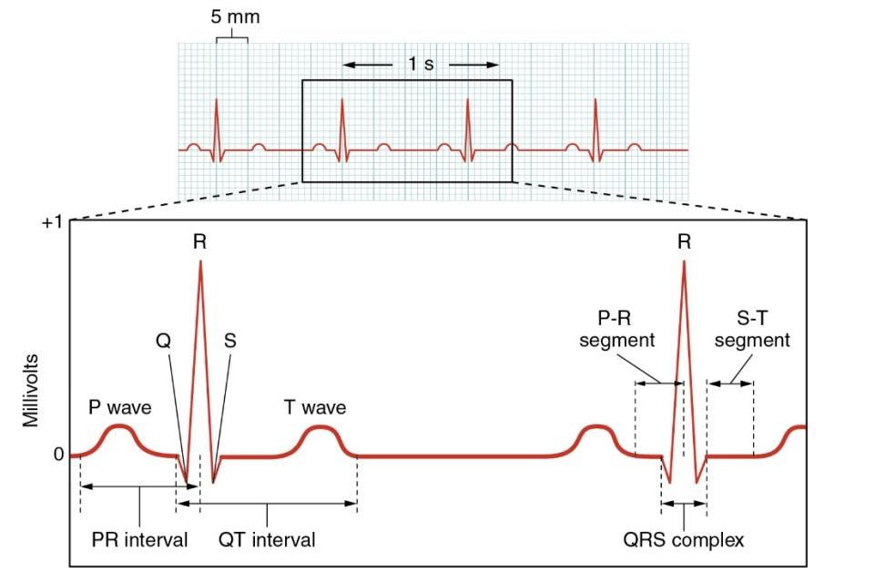
Figure 1: ECG tracing showing the P, QRS and T waves. Also indicated are the PR, QT, QRS, and ST intervals, plus the P-R and S-T segments.
Credit: Openstax Anatomy and Physiology

