Lab 5: Sensory System

Pre-Lab reading

this information was obtained from carolina biological: confusing the senses

Introduction:
We based what we know of reality on our perceptions of the world around us. These perceptions are the result of our interpretation of information received from our five basic senses: taste, touch, sight, hearing, and smell. The skin, mouth eyes, ears, and nose all contain nerve cells called sensory receptors. There are several categories of sensory receptors, including photoreceptors, chemoreceptors, thermoreceptors, mechanoreceptors, and nociceptors. When triggered, these receptors send information, to the brain, where interpretation of the stimuli occurs. Translating sensory stimuli into electrical stimuli called action potentials is called sensory transduction.
Most sensory signals travel first to a central location in the brain called the thalamus, and from there to the cerebral cortex, the layer of gray matter that is the exterior of the brain. The receptors for the senses are located in different locations in the cerebral cortex. After a signal is received, it must then be processed and interpreted; however, common phrases such as “I can’t believe my eyes” and “My mind is playing tricks on me” indicate awareness that sometimes our senses—or our perceptions of our senses—are not always completely accurate. In the following series of activities, you will test the limits of your senses and explore your mind’s ability to interpret sensory stimuli.
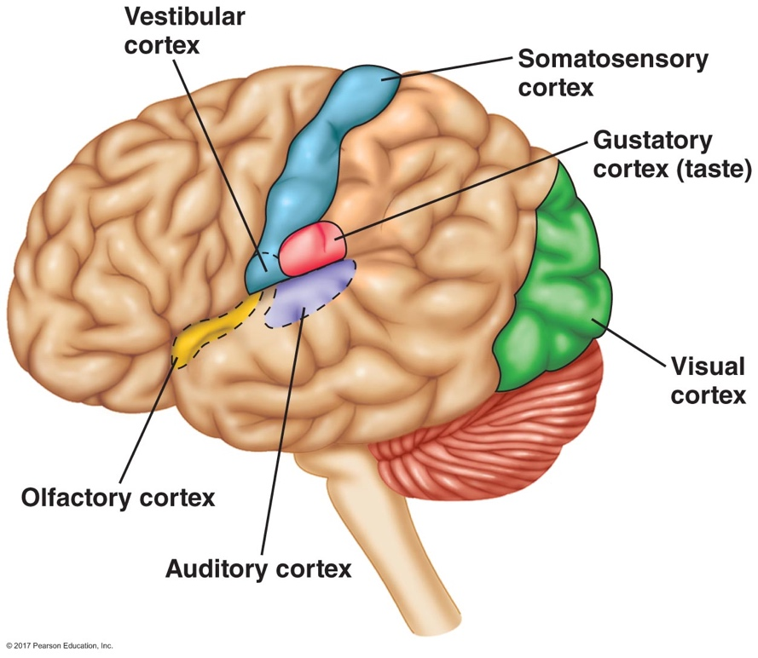
Thalamus
Figure 1. Cerebral cortex sensory map
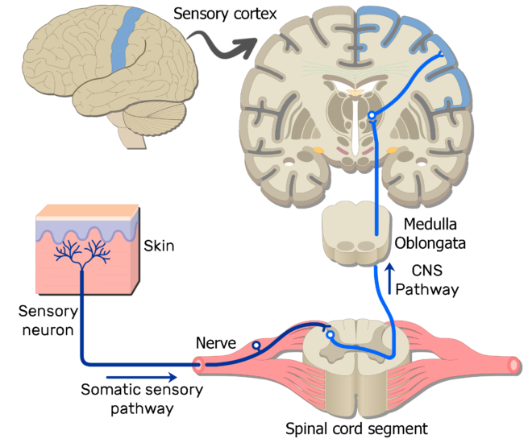
Figure 2. Figure 1. Simplified somatic sensation pathway

Confusing the senses:

Touch Activities
The skin is the largest sensory organ of the body and has many receptor sites for cutaneous sensations (from the Latin cutis, meaning “skin”). Different types of receptors in the skin respond to different kinds of stimuli including touch and pressure (mechanoreceptors), temperature (thermoreceptors), and pain (nociceptors). The ability to perceive these sensations is determined by the specific sensory receptors that are stimulated and their pathways to the brain. The distribution of receptors varies at different locations on the body surface. Those areas with high receptor density sense stimuli more accurately than those with low receptor density. Once a stimulus is detected by the nerve endings in the skin, information is passed to the spinal cord and then to the brain, where it is interpreted. . Most somatic sensations are mapped to specific regions in the parietal lobe of the brain, called the somatosensory cortex. The amount of cerebral cortex devoted to interpreting sensation from different areas of the body varies and correlates to our ability to distinguish sensations in each body area.
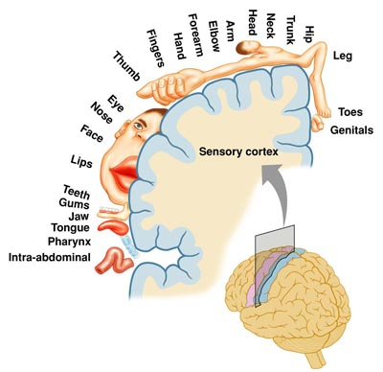
Figure 3. Somatosensory cortex map

Sight Activities
The eye is the sensory organ of the human visual system. It provides the ability to detect light and generate detailed images. Light waves pass through the cornea, aqueous humor, lens, and vitreous body before reaching the retina. As light travels through the eye, it is bent or refracted, allowing a large amount of light to be focused on a small area of the retina. The image of the object being viewed is projected upside-down and backward onto the retina. Within the retina are photoreceptor cells known as rods and cones, which are connected to neurons. These nerve cells send visual impulses to the brain via the optic nerve, where the brain’s primary visual cortex (in the occipital lobe of the cerebral cortex) processes and interprets the stimuli.
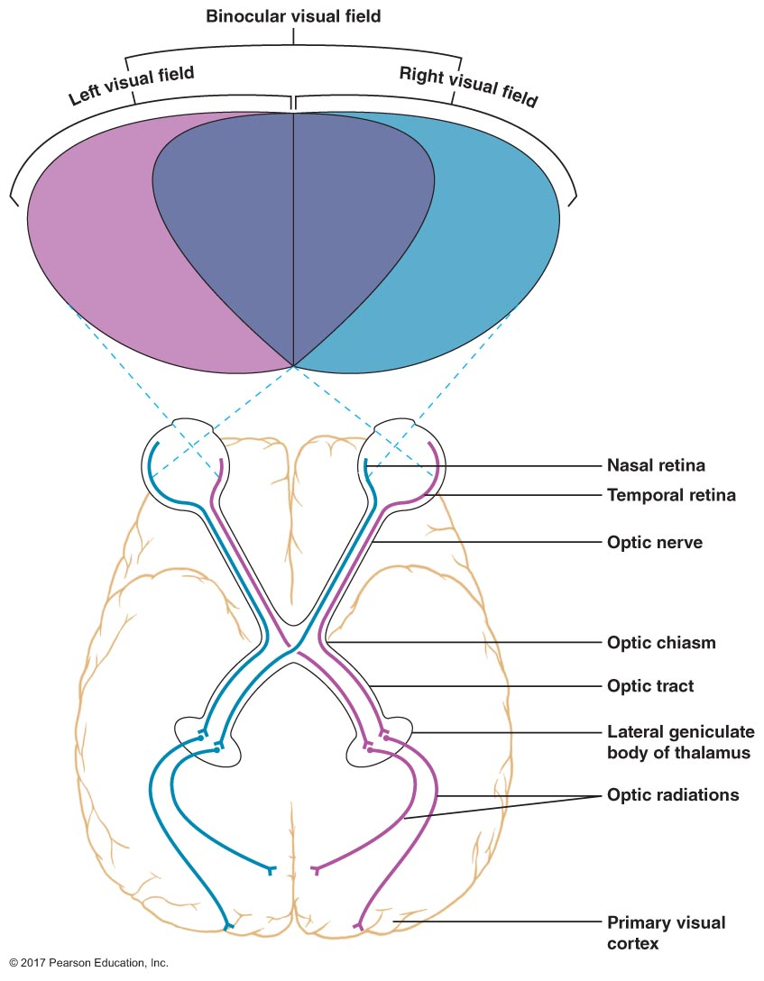
Figure 4. Optic pathway
Rods and cones on the retina serve different purposes in the human visual system. Rods function best under conditions of low light intensity and produce black-and-white vision only. Cones are responsible for color vision and require higher light intensities to operate. Thus, night vision is primarily black-and-white vision, with color muted. There are three types of cone receptors, and these are most sensitive to the visible primary colors of light: red, green, and blue. The different types of cones have different latency times and durations. For example, red receptors may respond faster than blue receptors, but blue receptors may respond to stimuli longer. When all three receptors respond at the same time, the color white is perceived. Rods and cones are not evenly distributed across the retina. The cones are concentrated in the fovea centralis, a small depression in the retina. Cones decrease in number with distance from the fovea. Rods are absent or nearly absent from the fovea, and they increase in abundance with distance from the fovea. As a result, we see little color in our peripheral vision. Near the fovea is the optic disk, which marks the point of attachment to the optic nerve. The optic disk contains no photoreceptors at all. The optic disk commonly is referred to as the “blind spot”, because when light falls on this area, an image cannot be seen, due to the lack of photoreceptors.
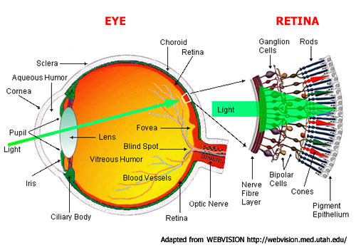
Figure 5. Eye anatomy and retina
Optical illusions can be defined as images that are deceptive, self-contradictory, or misleading. These visual tricks actually take place in the brain, not the eye. It is the job of the visual cortex to interpret the images focused on the retina and make sense of them. However, surrounding objects, intense colors, distortions of expected patterns, preconceptions, and many other factors can cause the mind to interpret an image differently or incorrectly. Afterimages are one type of optical illusion. This occurs when looking away after staring intently at certain images of colors. When an object is observed closely for a long time, the light stimulating the retina eventually causes the rods and cones to become fatigued, desensitizing that part of the retina. After looking away from the image, the less-stimulated cones in the affected area will still function. The affected portion of the retina continues to produce the image for up to 30 seconds, but because the stimulation comes from only the less-fatigued cones, it is perceived as an image with complementary or negative colors.

Smell and Taste Activities
It is hypothesized that human can recognize over 10,000 different smells, although describing scents is much harder than describing features of other senses, such as color or sound. Though the nose is credited with this sense, only a small patch of cells at the very top of the nasal cavity of both nostrils is actually responsible for odor detection. This olfactory epithelium contains millions of olfactory neurons that have tiny projections called cilia. Cilia have receptors that bind to specific odorant molecules in the air. When odorants bind to corresponding receptor molecules, the affected neuron sends a signal via the olfactory nerve to the olfactory bulb, a round projection beneath the frontal love of the brain. Information from the olfactory bulb is then interpreted by the olfactory region of the cerebral cortex. The sense of smell tends to adapt under conditions of continuous stimulation, leading to decreased sensitivity to an odor. This phenomenon is known as olfactory fatigue.
Surprisingly, the sense of taste is relatively limited when compared to the sense of smell. There are only four individual taste responses: sweet, sour, salty, and bitter. Recent research has suggested that there may be a fifth response called umami, which corresponds to savoriness. So why are humans able to perceive so many different flavors with so few taste responses? The answer is that most of the flavors we experience, along with the basic taste response, come from the odor of the food that travels through our nasal passages and through a passage in the back of the mouth to the olfactory epithelia. Therefore, taste buds or receptors on the tongue, corresponding to the particular taste responses, are stimulated once food molecules are dissolved in saliva or other solvents. Nerves conduct the information to the thalamus and then to the part of the cerebral cortex is interpreting the aroma of the food. The result is the perception of flavor. Other factors than can influence the sense of taste include food texture, preconceptions, and even our sense of hearing.

