Lab 4: Endocrine System

Pre-Lab Reading

The command center for the endocrine system is the hypothalamus, a small, penny-sized portion of the brain. The hypothalamus acts as an endocrine organ that secretes oxytocin and antidiuretic hormone (ADH, also known as vasopressin). These hormones travel down the infundibulum (pituitary stalk) to the posterior pituitary gland where they are released directly into the bloodstream. In addition, the hypothalamus also regulates anterior pituitary gland function through the secretion of releasing hormones, including: thyrotropin-releasing hormone (TRH), corticotropin-releasing hormone (CRH), and gonadotropin-releasing hormone (GnRH).
These releasing hormones travel through a specialized blood vessel system (known as the hypophyseal portal system) that connects the hypothalamus to the anterior pituitary gland. From here, they stimulate the synthesis and secretion of anterior pituitary hormones, which include thyroid-stimulating hormone (TSH), luteinizing hormone (LH), follicle-stimulating hormone (FSH), growth hormone (GH), adrenocorticotropin hormone (ACTH), and prolactin. Each of these hormones is released into the bloodstream to affect specific target organs. For example, the hypothalamus secretes TRH, which travels to the pituitary gland to release TSH; TSH travels to the thyroid gland (the target organ) and stimulates the release of thyroid hormones (T3 and T4). It is important to note that the hypothalamic releasing hormones are only required for the synthesis and release of the anterior pituitary hormones. The posterior pituitary hormones are synthesized by the hypothalamus and travel down neurons to be released from the posterior pituitary gland. Because the anterior pituitary gland secretes multiple hormones, it is frequently referred to as the ‘‘master gland.’’
The release of hormones from the endocrine system can be regulated through positive or negative feedback mechanisms. The negative feedback system can be compared with a thermostat set at a predetermined temperature (68°F). When the temperature rises above the set point (72°F), the thermostat detects the change and activates the air conditioner to cool the room. The thermostat will turn the air conditioner off once the temperature of the room drops below the set point (67°F). To keep the room at a fairly constant temperature, the thermostat assesses the situation and turns the air conditioner on or off accordingly.
In the endocrine system, negative feedback is used to inhibit further hormone secretion. When a sufficient amount of hormone has been released, it communicates or ‘‘feeds back’’ to suppress the releasing organ. In other words, the gland has released enough hormone to fulfill its function; this is sensed by the body, and production of the hormone ceases. Negative feedback not only inhibits the releasing organ but can also inhibit the pituitary gland and/or hypothalamus. By using a negative feedback system, the body produces only the amount of hormone it needs without wasting its resources. Conversely, in positive feedback, the end product further stimulates the releasing organ. This form of feedback is less common and will not be covered in the lab.
The pathways of three hormones are examined in this week’s lab: thyroid hormone, cortisol, and testosterone. The hormonal pathways are similar in all three cases. It is important to realize that the hypothalamus secretes a releasing hormone to regulate each of the hormones secreted from the anterior pituitary gland. In this way, the hypothalamus is like a command center. If the hypothalamus is not stimulated, the hypothalamic releasing hormones (TRH, CRH, and GnRH) will not stimulate the anterior pituitary gland to secrete its hormones.
The hypothalamus releases TRH, which travels to the anterior pituitary gland via the bloodstream to stimulate production of TSH. TSH travels to the thyroid gland (located by the trachea) to stimulate the production and release of thyroid hormone. Thyroid hormone influences the growth rate of many body tissues and is necessary for proper central nervous system development. Its main function is to increase a person’s basal metabolic rate (BMR) and to increase heat production. An excess of thyroid hormone can negatively feedback to inhibit further thyroid hormone release from the thyroid gland, TSH secretion from the anterior pituitary gland, and/or TRH release from the hypothalamus.
Similarly, ACTH is released from the anterior pituitary gland in response to CRH secreted from the hypothalamus. ACTH stimulates the adrenal glands (located on top of the kidneys) to secrete cortisol, which promotes the breakdown of proteins and fats and helps the body adapt to stress. Cortisol functions to provide the body with fuel by breaking down (catabolism) the materials of the body. Under normal conditions, excess cortisol in the bloodstream will negatively feed back to the hypothalamus (to inhibit CRH release), anterior pituitary gland (to inhibit ACTH secretion), and/or to the adrenal gland (to inhibit further cortisol release). The release of CRH is regulated by negative feedback, circadian rhythms, and stress. Cortisol can also act as an immunosuppressive and anti-inflammatory agent. If cortisol is administered in large doses, its immunosuppressive properties will cause the organs of the immune system to shrink. In this lab, the thymus gland will represent the organs of the immune system.
LH is released from the anterior pituitary gland in response to GnRH (gonadotropin releasing hormone) secreted from the hypothalamus. LH is seen in both males and females. In the male, LH travels to the Leydig cells of the testes. The Leydig cells release testosterone, which is responsible for the male sex drive and secondary sex characteristics, such as increased body hair and a deeper voice. An excess of testosterone can cause an increase (anabolic) in muscle mass. Negative effects of testosterone are male pattern baldness and increased secretion of the sebaceous glands, which can lead to acne. To simplify the relationship between the reproductive and endocrine systems, we will concentrate only on the male system. The female reproductive system is more difficult to study than the male reproductive system because it is continuously cycling.

The pathways of all three hormones can be understood by looking at a visual representation in Fig. 1 (Figure 1 also demonstrates the pathways of the hormones that will be used throughout the experiment, thus serving as an aid in the analysis of laboratory data).
The glands and tissues of our body enlarge (increase in size) if they are continuously activated; this is called hypertrophy. For example, a person who lifts weights will continually stimulate the activated muscles, resulting in hypertrophy. This can be easily observed when comparing a bodybuilder to an average person; the bodybuilder’s muscles appear larger in comparison. In contrast, if a gland or tissue is continuously inhibited it will shrink in size or atrophy. For example, if a cast is placed on a person’s arm for 6 weeks and then removed, a drastic reduction in muscle mass can be seen. The cast prevented any movement (stimulation) of the limb, allowing atrophy to occur.

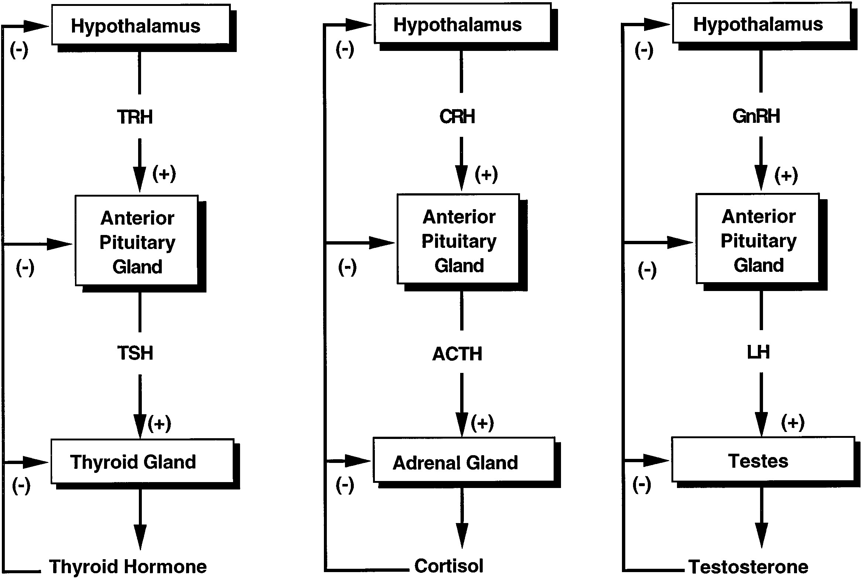
FIG. 1.
Negative feedback control (hormone pathways).

There are many diseases that may result from a deficiency or excess of hormones. These hormonal imbalances may lead to changes in organ or gland size (hypertrophy or atrophy). Hyperthyroidism is the excessive production of thyroid hormone. The most common cause of hyperthyroidism is Grave’s disease; the symptoms include increased BMR, a constant feeling of warmth, nervousness, and an enlarged thyroid gland (known as goiter). In contrast, hypothyroidism is the result of decreased levels of thyroid hormone. A patient with hypothyroidism will present symptoms of low BMR, a decreased appetite, abnormal central nervous system development, and an intolerance to cold.
Cushing’s syndrome is the result of excess secretion of cortisol (hypercortisolism). The symptoms of Cushing’s syndrome include personality changes, hypertension (high blood pressure), osteoporosis (weakening of bones due to loss of calcium), and initial weight loss, followed by weight gain in the long-term, as metabolism drops. If an excess level of cortisol remains in the body, protein degradation will occur leading to a ‘‘wasting’’ effect as muscle mass is lost. Hyposecretion (decreased secretion) of cortisol is characterized by symptoms such as defective metabolism, mental confusion, and a decreased ability to adapt to stress.
Decreased amounts of testosterone in the body primarily affect the sexual organs. If testosterone levels are low, males will not develop normally and will have sperm counts too low to fertilize an egg. The condition of excess levels of testosterone is rare but causes premature sexual development.

