Lab 4 Protocol: Endocrine System
This exercise is designed to determine the identity of an unknown hormone by observing the effect it (the hormone) had on the organs of the male rat.

Activity 1 - PREDICT impact of hormone treatment on the organ weights and body weight
The class should be divided into small groups of three or four students per group. Each student in the group should receive a copy of Table 1. Using the background material, the students should complete Table 1, in each column predicting the impact of specific hormone treatment on the weights of various organs. Not all hormones will have impacts on all organs. A + denotes an increase in size. A - denotes a decrease in size. Place the letters NC in the box where no change occurs. Leave the cell blank if the hormone is predicted to have to impact on the organ. Have your instructor check your predictions.

TABLE 1- Comparison of hormonal effects on organ weight and body weight (to be completed by students)
 | TRH | TSH | ACTH | Cortisol | Testosterone intact | Testosterone castrate | LH intact | LH castrate
Pituitary gland
Thyroid gland
Adrenal glands
Thymus gland
Testes
Prostate gland
Seminal vesicles
Body weight
**In each column, predict the impact of treatment with the indicated hormone on weight of the organs indicated. Not all organs will be impacted by all hormone treatments. A + denotes an increase in size. A - denotes a decrease in size. Place the letters NC in the box where no change occurs. TRH, thyrotropin-releasing hormone; TSH, thyroid stimulating hormone; ACTH, adrenocorticotropin hormone; LH, luteinizing hormone

Activity 2. Identify unknown treatment hormone from autopsy data
After completing Table 1, the instructor will present each group with autopsy data from
control rats and rats treated with an unknown hormone. The students will then use the
background material, flowchart (Fig. 4), Table 1, and the autopsy data to determine the identity of the unknown hormone. At the end of class, the students will present their solution and rationale for their identification of their unknown hormone. If time permits, the students are encouraged to determine the identity of the remaining unknowns and provide a solution and rationale for each hormone.

Your instructor will present each group with autopsy data from control rats and rats treated with an unknown hormone. The data for this laboratory were compiled from seven sets of male laboratory rats, two rats per set; one set was the control group and the remaining six were experiment groups. The rats were all males. In each set of rats there was and “intact” rat and a “castrate” rat. The castration involved removal of the testes to eliminate testosterone production. The two rats (normal and castrate) of each group were treated alike in all other ways (food, water, etc.). All rats, except for those in the control group were injected with a hormone on a daily basis for 2 weeks. Autopsies were performed on the animals at that time.
The group of students performing this laboratory experiment were very disorganized and rushed through the work, making errors in labeling the bottles of hormone. The students obtained the following results for organ weights after the autopsies were performed. In this short period of time, the students noted amazing changes in the size of certain organs when they compared the experiment group of rats with the control group. The bottles on the refrigerator shelf were ACTH, cortisol, LH, TSH, TRH, and testosterone.
Your group will be given data from a pair of control rats (intact and castrate) and the remaining six pair (intact and castrate) of experimental rats. It is your group’s job to analyze the data and compare control and experimental data to determine which of the above hormones was used to treat your experimental rats. Your job is to match the unknown rat groups with their respective treatment hormones.
To help in determining the identity of the unknown hormones, the student should look for changes between the control values of the unknown hormone (both the intact and castrate rat). The changes between the control rats that were treated with the unknown hormone should be >20% if they are to be considered significantly different. If the change is <20%, it is attributed to experimental or biological error. Experimental errors may include small errors in calibration procedures, measurements, or instrumentation. Any variability that occurs because of the differences between animals is considered biological error.

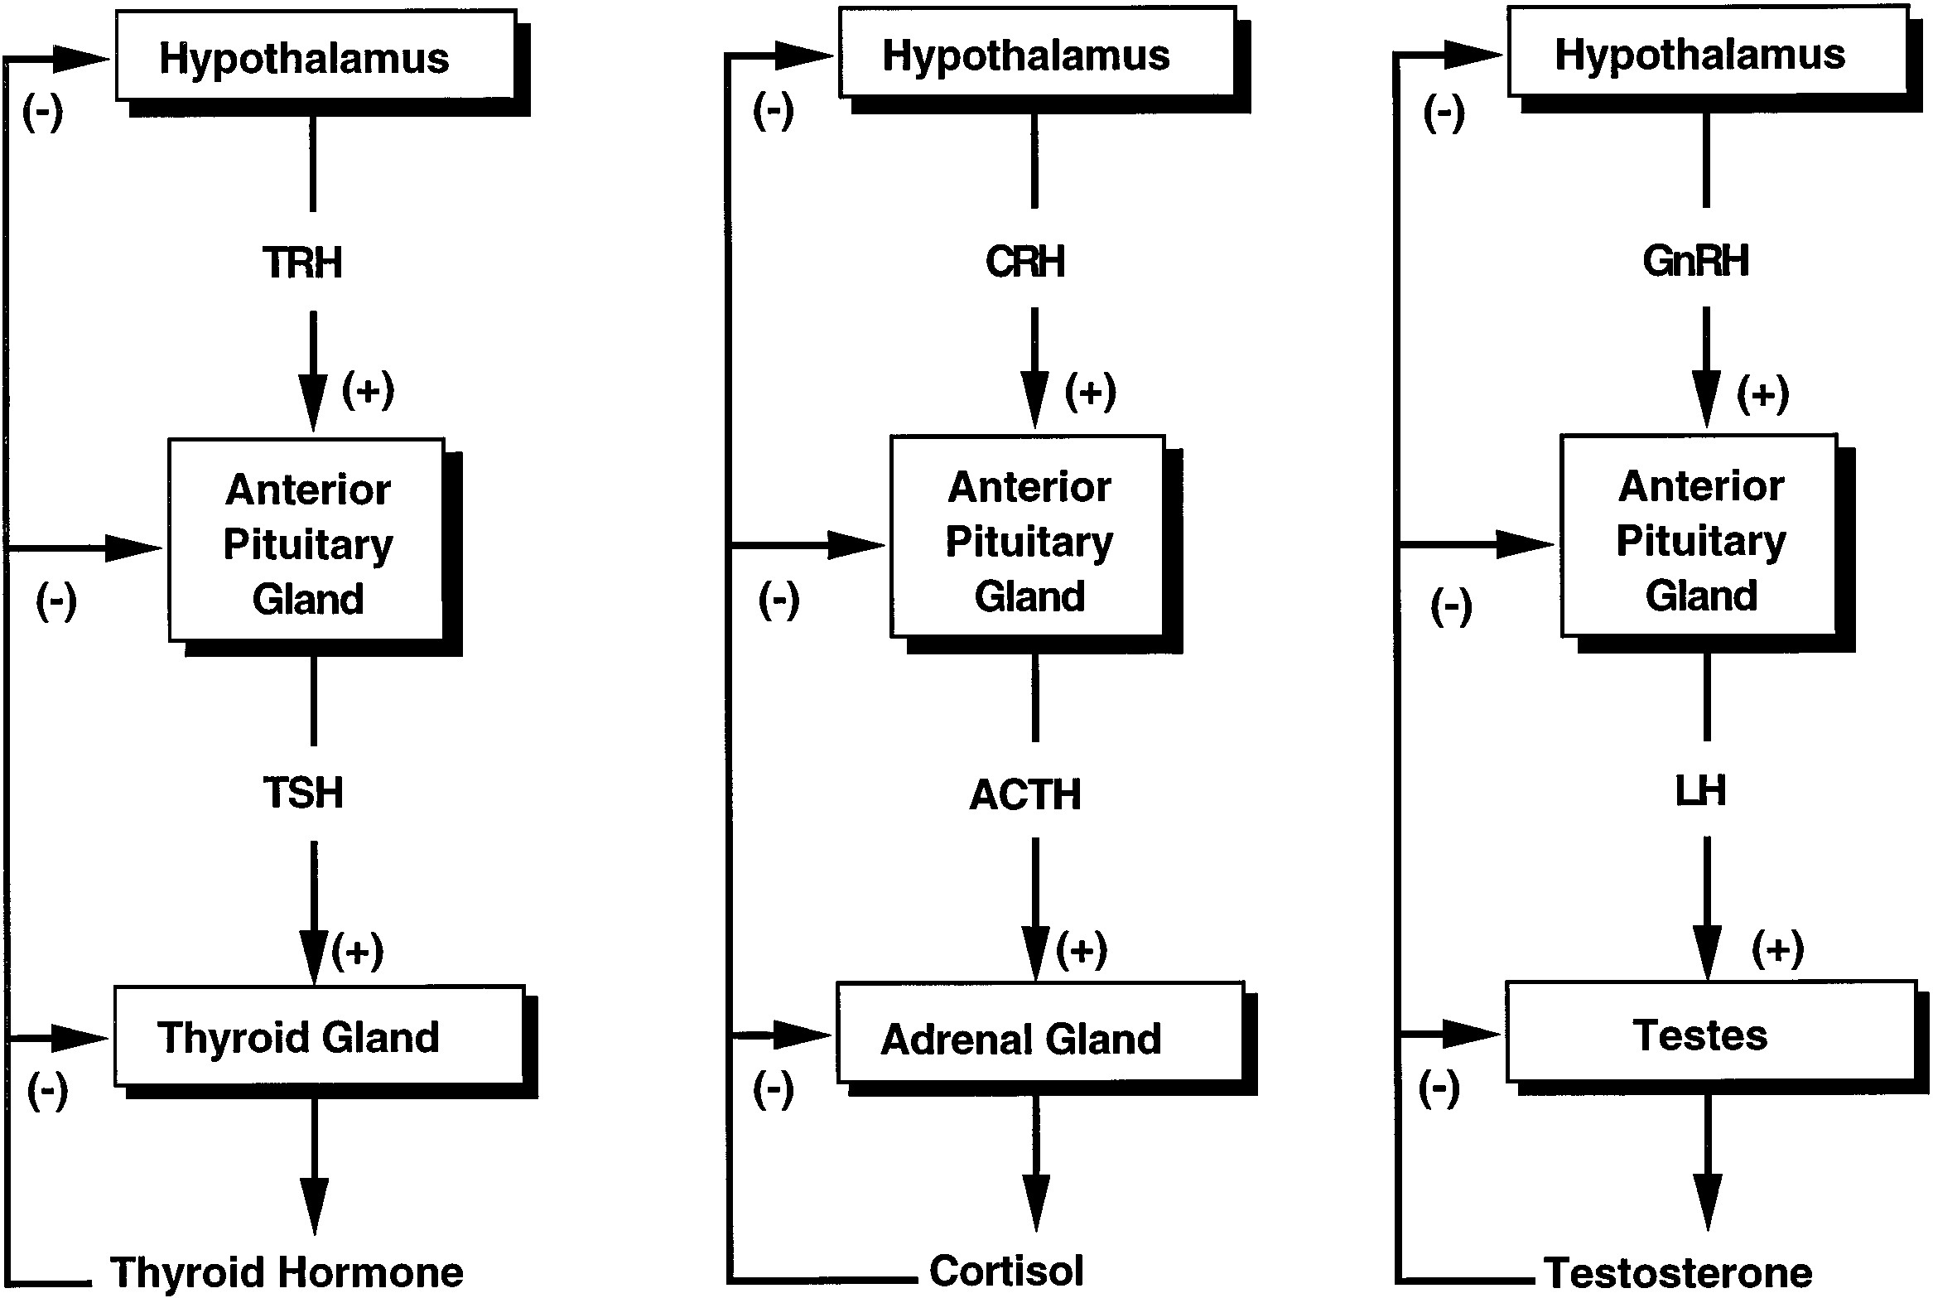
Figure 4: Negative feedback control (hormone pathways).

