Lab 3: Cell transport

ACTIVITY 1A. Selective Permeability and Osmosis
- Osmometer Demonstration (TO BE DONE AS A CLASS)
Students will collect data from a demonstration.
There will be three osmosis apparatuses, labeled A, B, and C. The three thistle tubes in the demonstration are filled with 15% sucrose, 30% sucrose, or distilled water. The three beakers are filled with distilled water. You will determine which tube is filled with which solution.
The initial position of liquid in each tube will be marked. Subsequent measurements of the height of the liquid above the initial position (in mm) will be recorded on the board. Record measurements every 10 minutes for the next 90 minutes. Each group should take at least one measurement but be sure that you have recorded all measurements and times on the data sheet that is provided later in this lab.

ACTIVITY 1B. Dialysis across a Semi-Permeable Membrane
Students will collect data with a partner.
Prepare a small beaker about half full of warm water, and place about 10 drops of iodine in the beaker. Then tie one end of a dialysis bag with several knots, making sure it is very tight. Fill the bag with 10 ml of starch solution. Place the knotted end of the bag in the beaker that contains the iodine, with the other end of the bag hanging over the side.

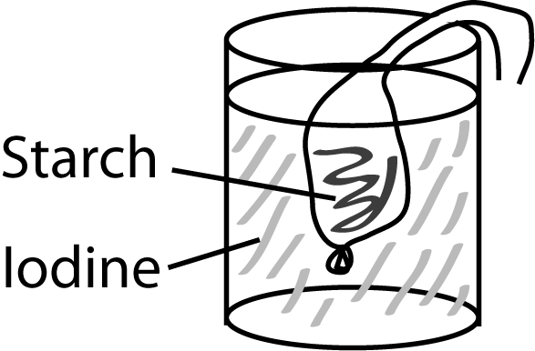
After several minutes (5- 10 minutes), note any changes in the color of the solution in the dialysis bag and the color of the solution in the beaker outside the bag. Record your observations.
Fluid inside bag: ______________________________________________________
Fluid outside bag: _____________________________________________________

ACTIVITY 1C. Red Blood Cells as Osmometers
Students will collect data with a partner.
1. Make a stock red blood cell (RBC) solution by diluting 20 drops of blood in 10 ml isotonic saline. Make sure the solution is well mixed because the cells tend to settle to the bottom of the tube. Do not throw this stock solution away because you will use it again in Activity 2.
2. Obtain and label three test tubes (A, B, and C) and place 2 ml of the following solutions into the different tubes:
A. distilled water
B. 0.9% NaCl
C. 2.0% NaCl
3. Add 0.1 ml of the stock RBC solution (from step 1) to test tube A. Immediately place a piece of lined notebook paper with letters on it behind the tube and determine whether the letters can be distinguished or not. Record the results here for later transfer to the data sheet. Repeat this for test tubes B and C. Are the letters behind the tubes clear or cloudy?
4. After 5 minutes, mix the tubes well. Again, place a piece of lined notebook paper with letters on it behind the tube, and decide whether the solution is clear or cloudy.
5. Transfer a drop of each solution (after the RBCs have been added) to labeled microscope slides, add a cover slip to each slide, and observe the appearance of the cells under the microscope. Record your observations.
6. Based on the appearance of the cells in the microscope, determine the tonicity of each solution to RBCs.
 | Distilled Water | 0.9% NaCl | 2.0% NaCl
Clarity of letters behind tube (time = 0 min)
Clarity of letters behind tube (time = 5 min)
Microscopic appearance (after 5 min)
Tonicity of each solution to RBCs

Activity 2. Effect Of Molecular Weight and Lipid Solubility on Membrane Permeability
Students will collect data with a partner.
1. Obtain and label 6 test tubes. The experiment will be done in triplicate using 2 different alcohol solutions: methanol (tubes 1-3) and butanol (tubes 4-6). Place 2 ml of the appropriate alcohol into each tube.
2. Mix your RBC stock solution (from Activity 1C) and add 0.1 ml of it to one of the alcohol tubes. Observe and record the time needed for hemolysis to occur (the solution becomes clear). This will happen within seconds, so you must begin timing immediately after adding the RBCs. Repeat this for each of the remaining 5 tubes. Record your observations
 |  |  | OBSERVED | CALCULATED
ALCOHOL | HEMOLYSIS TIME | HEMOLYSIS RATE | AVERAGE HEMOLYSIS | DIFFUSION RATE expected
mw; lipid solubility | (sec) | (1/sec) | RATE (R)  (slow or fast) | by Molecular Weight alone
METHANOL
32g/mole; 80 g/l
BUTANOL
74g/mole; 6000 g/l

3. Convert the hemolysis time into a rate ("per second") by dividing 1 by the hemolysis time.
1 divided by hemolysis time = HEMOLYSIS RATE
1 divided by the square root of molecular weight = DIFFUSION RATE

POPS PROJECT:

Keep track of what you drink and the amount in a 24-hour period. Total volume consumed in ounces. (how many ounces of water, coffee, soda, alcohol……) Be very specific with the amount and type of drink.

