LAB 8 PROTOCOL: Blood pressure and characteristics

ACTIVITY 1. Effect of Body Posture on Heart Function
To determine blood pressure:
Place a pressure cuff around the upper arm 1 inch above the junction of the elbow. Inflate the cuff to approximately 160 mmHg to completely occlude the brachial artery. While listening with the stethoscope’s diaphragm over the brachial artery distal to the occlusion, slowly release, at approximately 3 mm Hg/second, the pressure until an intermittent sound is heard. This first sound indicates the systolic pressure. Continue to release the pressure until the sound disappears. The point at which the sound disappears indicates the diastolic pressure.
Warning: This procedure involves stopping blood flow to the arm, which is potentially dangerous. If there are enough students in the lab with experience in this procedure, they may assist inexperienced students. Please take the following precautions:
- Know what you are doing ahead of time.
- Do not leave the cuff inflated for any prolonged period of time (>30 seconds).
- The volunteer should flex and extend their fingers between experiments to maintain blood flow.
- This experiment should be performed on healthy individuals who do not have a personal or family history of cardiovascular or respiratory disease

To determine pulse:
We will determine pulse rates manually and with the pulse oximeter. To take a manual pulse, place your fingers (not your thumb) on the thumb side of your partner's wrist at the radial artery. Place the pulse oximeter on a finger on that hand. Count the pulse for 15 seconds and multiply this number by 4 to obtain the beats per minute. The pulse can also be monitored on the neck (carotid artery).
Caution: great pressure is not required to monitor the pulse, and, in fact, too much pressure may produce a change in the pulse rate. Never monitor a subject's pulse with your thumb, because you may feel YOUR OWN pulse, from the artery in the thumb.
Measure you and your partner’s pulse and blood pressure in three different conditions:
supine (after 10 minutes), standing (immediate), and standing (after 5 minutes). Determine your pulse both manually and with the pulse oximeter, while your lab partner determines your blood pressure and records data on your data sheet. For each of the pulse rate determinations, obtain an average of 3 separate recordings (for each), and record it in the spaces provided. Then switch and take readings on your lab partner.
Pulse (bpm) Pulse (bpm) Blood Pressure
(manual) (pulse oximeter) (mm Hg)
Supine
(10 min.) __________ ______________ _______________

Standing __________ ______________ _______________
(immediate)

Standing
(5 minutes) __________ ______________ _______________

ACTIVITY 2. Effect of Exercise on Heart Function (done as a group)
- Record the normal resting (standing) pulse rate (using the pulse oximeter) and blood pressure of a volunteer in the group (Use your standing 5-minute values from Activity 1) under ‘Normal’ on the data sheet.
- With the deflated pressure cuff in place, have the group’s volunteer perform a standard exercise for one minute using a step-up test, squats, running in place, jumping jacks, or whatever other exercise you want to do that will increase your heart rate.

**IF YOU FEEL THAT YOU SHOULD NOT DO THIS EXERCISE ACTIVITY, PLEASE FEEL FREE TO OPT OUT OF IT.

- After exercise, the volunteer will monitor his or her own pulse rate (using the pulse oximeter) while you monitor his or her blood pressure. After one minute of exercise the subject stops and the pulse rate and blood pressure are monitored immediately.
- Continue to determine the pulse rate every 15 seconds for two minutes or until the recovery heart rate reaches the pre-exercise value. Determine the blood pressure at one minute and two minutes following exercise.
- Record your results in the table on the data sheet:

Pulse Systolic Pressure Diastolic Pressure
(bpm) (mm Hg) (mm Hg)

Normal _________ ______________ _______________

Immediately after exercise (Time = 0)

0 Sec _________ ______________ _______________

15 Sec _________

30 Sec _________

45 Sec _________

60 Sec _________ ______________ _______________

75 Sec _________

90 Sec _________

105 Sec _________

120 Sec _________ ______________ _______________

Continue taking readings until normal values are reached:

Time necessary to reach normal pulse ______________________________

Time necessary to reach normal blood pressure ______________________________
POPS PROJECT:
Record your blood pressure in a supine position, immediate after standing, and after standing for 5 minutes. Resting beats per minute 5 times. Standing beats per minute, exercising beats per minute, exercising systolic pressure, exercising diastolic pressure, sitting systolic pressure, sitting diastolic pressure, standing systolic pressure and standing diastolic pressure.

ACTIVITY 3. Active Hyperemia and Reactive Hyperemia

A. Active Hyperemia
Active hyperemia can also occur when one becomes embarrassed. Strong emotions stimulate the sympathetic nervous system, which causes the arterioles in the cheeks to dilate and increase blood flow to the skin.
Imagine that the entire class were now drawing its attention to someone in the group who might blush with such attention. (If someone who is prone to blushing actually wants to volunteer to be the center of attention, they may do so). Record on the data sheet what you see when the person blushes.
A. Active Hyperemia
Record here what you would observe on the embarrassed person’s face

__________________________________________

B. Reactive Hyperemia
To see local reactive hyperemia, observe the reaction 3-4 minutes after an individual has rested with the cheek (zygomatic arch) against the fist or the palm of the hand with the elbow propped on the desk top. Record on the data sheet the skin color on the cheek that you observe immediately after the hand (obstruction) is removed and what color the skin changes to shortly afterward.

B. Reactive Hyperemia
Record here what you observed after 3-4 minutes of the person resting her cheek on her hand

ACTIVITY 4. The Buffering Capacity of Blood
To measure pH, carefully take the electrode probe out of the water, rinse the probe with a stream of distilled water from a plastic rinse bottle and blot the excess water from the probe with a Kimwipe tissue, then place the probe into the solution to be tested. This procedure of washing and blotting is followed each time the probe is removed from the water beaker or from a pH test solution.
You will compare the buffering capacities of (1) whole blood (which has been diluted by 50% with 0.9% NaCl), (2) blood plasma (which has been diluted by 50% with 0.9% NaCl), and (3) a saline solution. The blood you will use is heparinized or citrated (anticoagulants) mammalian blood. The plasma is collected from this whole blood by centrifugation.
- Place 5 ml each of the whole blood solution, the plasma solution, and the saline solution separately into three of the 20 ml beakers provided.
- Position the probe of the calibrated pH meter in the saline solution and measure the pH of the saline solution. Record on the data sheet.
- Leave the probe in the saline solution with the meter. Using the calibrated pipette or burette provided, add 0.01 M HCl to the saline solution while cautiously swirling the beaker. On the data sheet record the exact fraction of a milliliter of acid required to lower the pH of the saline solution by one pH unit.
- Set the meter to standby and rinse and blot the probe as described above.
- Determine the pH of the whole blood solution and record it on the data sheet.
- Determine and record on the data sheet the ml of acid required to lower the pH of the blood solution by half a pH unit.
- Determine and record on the data sheet the pH of the plasma sample.
- Determine and record on the data sheet the ml of acid required to lower the pH of the plasma by half a pH unit.

Saline Solution
pH of saline solution: ___________________

Record the exact fraction of a milliliter of acid required to lower the pH of the saline solution by one pH unit. ___________

Whole Blood
pH of whole blood: __________________

Record the ml of acid required to lower the pH of the blood solution by half a pH unit. ___________

Plasma
pH of plasma: ________________

Record the ml of acid required to lower the pH of the plasma by half a pH unit. ____________

ACTIVITY 5. Determination of Blood Hematocrit and RBC Count
In this activity, you will determine the hematocrit using capillary tubes and a centrifuge, and you will determine the red blood cell count using a hemocytometer.

Hematocrit Determination
- Place the blood samples in the heparinized capillary tubes into a numbered radial slot position of a centrifuge fitted with a capillary tube head. Position the capillary tube with the clay seal away from the center of the capillary tube head. Remember the number of the position of your capillary tube. When the head is filled with capillary tubes carefully screw down the cover of the centrifuge and spin the samples for 3 minutes.

- When the centrifuge has stopped spinning (Caution: allow the head to stop of its own momentum and do not try to stop it sooner, or you might re-mix the solution), take your (check your number) capillary tube and hold it vertically with the clay-sealed end down. Observe the upper clear plasma, the lower portion of packed red blood cells (RBCs), and the thin boundary of white blood cells (WBCs) that separates the RBCs from the plasma. Another precaution: after you remove the capillary tube from the centrifuge read the hematocrit as soon as possible. If that is not possible, store the capillary tube in a vertical position.

- To determine the Hct of your sample use the hematocrit scale chart if available and follow the directions. Otherwise, use a small plastic ruler to measure to the closest estimated fraction of a millimeter the following:
  - Measure the height of the whole blood column of from the clay/blood junction at the bottom of the tube to the meniscus of the plasma at the top of the blood column. Record the total height of the whole blood column on the data sheet.

  - Next measure the height of the column of packed RBCs from the clay/blood junction at the bottom of the tube to the top of the RBCs at the WBC/RBC junction. Record the height of the RBC column on the data sheet.

  - From these values calculate the Hct by the formula:
Hct = (height of RBC column / height of whole blood column) X 100

Hematocrit Determination
Height of RBC column = _______________
Height of whole blood column = _______________
Hematocrit = _______________

Red Blood Cell Count
Caution: the hemocytometers AND their coverslips are very expensive. Please handle them with care and DO NOT throw the coverslips away.

Obtain a hemocytometer and place the coverslip on it. Apply your diluted blood sample to the groove on the hemocytometer by touching the tip of the pipette to the groove. By capillary action, the sample will be drawn under the cover slip. Do not move the coverslip once you have added your sample.
To determine the red blood cell count, place the hemocytometer on the microscope stage and focus on the lines under low power. Red blood cells will be counted in the 5 squares that are shaded in Figure 7. You will then sum the counts from these 5 squares. The large central square in which your five small squares are located has an area of 1 mm² and the depth of your sample under the coverslip is 0.1 mm. Therefore, if you had counted all 25 small squares, you would have obtained the number of red blood cells in 0.1 mm³ of your sample. Since you only counted 5 squares, you need to multiply your number by 5 to obtain the number of red blood cells in 0.1mm³ of your sample. You also need to multiply by 10 to determine the number of RBCs in 1 mm³ rather than just the 0.1 mm³ sampled in the hemocytometer. Finally, since you diluted your sample 200 times, you will need to multiply your count by 200 to obtain the number of red blood cells in 1 mm³ of whole blood.

RBC count = number of RBC/mm³ of blood = (sum of counts in 5 squares) x 5 x 10 x dilution factor (in this case 200 or 20)

When counting the red blood cells, begin in the upper right corner of one of the squares (notice that each of the 5 squares that you will be counting is subdivided into 16 even smaller squares to help you keep your place as you are counting cells). Count the cells in the upper row of tiny squares moving from left to right and then count the second row of tiny squares from right to left. The third row is counted from left to right and the fourth row is counted from right to left. For accuracy, any cell that is on a line is only counted in the square in which it is on a left or upper line. Any cell on a right or lower line of a square is not counted. See the figure below for a diagrammatic representation of the order of counting. Note there is an iPhone app called HemocyTap that can help you with this.
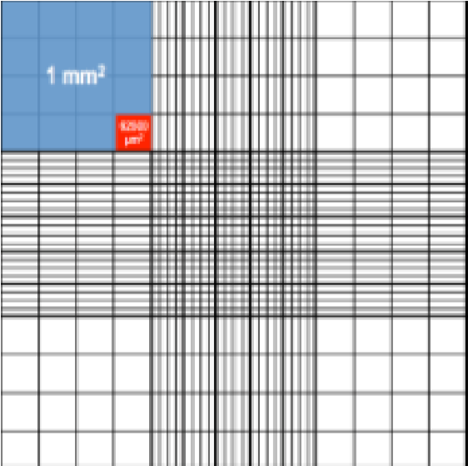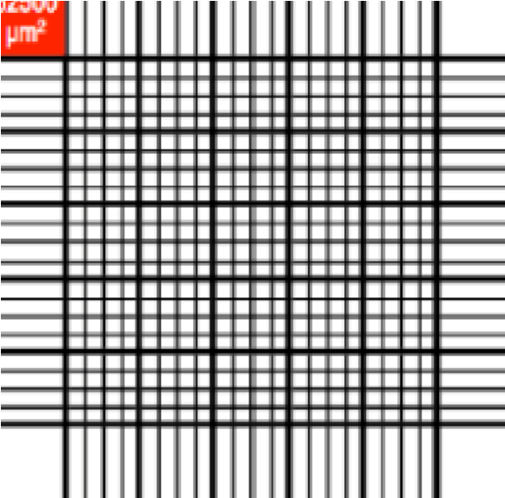
→

RBC count = __________________

RBC count = number of RBC/mm³ of blood = (sum of counts in 5 squares) x 5 x 10 x dilution factor (in this case 200 or 20)

