LAB 11 PROTOCOL: SPIROMETRY
For this exercise, the 214 device will be required. Be certain that the USB cable from the back of the unit is plugged into the front of the computer and the power switch on the back of the unit is on. Plug the spirometer into CH4 input of the 214 unit.
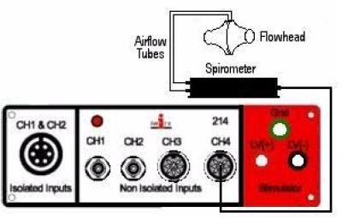

Figure 1. The Spirometer connection to the iWorx214 unit. Note that the airflow tubes arise from the top of the flowhead. Keep these airflow tubes upright.

Click on the LabScribe icon on the Desktop. Select Load Group from the SETTINGS menu. Click again on SETTINGS. Click on COMPLETE SETTINGS – IPLMv6Cplete.iwxgrp. Click LOAD/OPEN. Select SETTINGS again. Click on Human Spirometry. Select Breathing-Rest Exercise

You are now set up for the Spirometry exercise.

**By clicking the RECORD button in the top right, you will begin the recording sequence. Allow 10 seconds for the spirometer to equilibrate before recording data. Inhalations should be in an upward direction and exhalations should be in a downward direction. Just reverse the spirometer, if necessary.

**You may need to reset the screen periodically. This can be done by going to the FILE icon on the tool bar and clicking NEW. But DO NOT SAVE any information as this just uses up space on the hard drive of the computer.

It is important that the volunteer is healthy and has no history of respiratory or cardiovascular problems.

Exercise 1: Breathing in a Resting Volunteer
- The subject should sit quietly with the flow head held at mouth level. Do not yet breath into the flowhead but hold it still to the side of the mouth. Remember to hold the flowhead so that the outlets are on top.

- Click START/RECORD to begin the graph. Every time you start the graph the respirometer will calibrate itself, causing a spike to appear on the graph. The calibration period requires at least 3 seconds. During this time, there can be no air moving through the flowhead.

- After the calibration period (3 seconds after clicking START/RECORD, begin breathing into the flow head. These are normal resting breaths (tidal volumes) and should NOT BE FORCED. Make sure the graph deflects upward for inhalation and down for exhalation. If you observe the opposite, then you are using the wrong end of the flow head. After 3 or 4 breaths, click STOP to halt recording.

Note: Try to record your data within 30 second time frame. The respirometer will automatically calibrate itself every 30 seconds and create a new spike which could interfere with your graph.

- Click AUTOSCALE. Within the volume window, you should see one or more breath cycles. Use the HALF DISPLAY OR DOUBLE DISPLAY TIME icons from the toolbar near the top of the screen to fit two breaths within the graph window.

Exercise 2: IRV and ERV

- Start with a new graph by selecting FILE from the menu list (upper left of the screen), then NEW. When prompted to save your previous data, select NO.

- This time you will take 2-3 tidal volume breaths, then quickly inhale as much as possible and forcibly exhale the entire volume until it hurts! After clicking START/RECORD, remember to wait 3 seconds before breathing into the mouthpiece. After the expelling all the air from your lungs, click STOP to halt recording.

- Select AUTOSCALE and scroll your graph back so that the last tidal volume and the entire force volume is showing in the Volume window.

POPS PROJECT:

Measure Tidal Volume, Vital Capacity, ERV and IRV.

