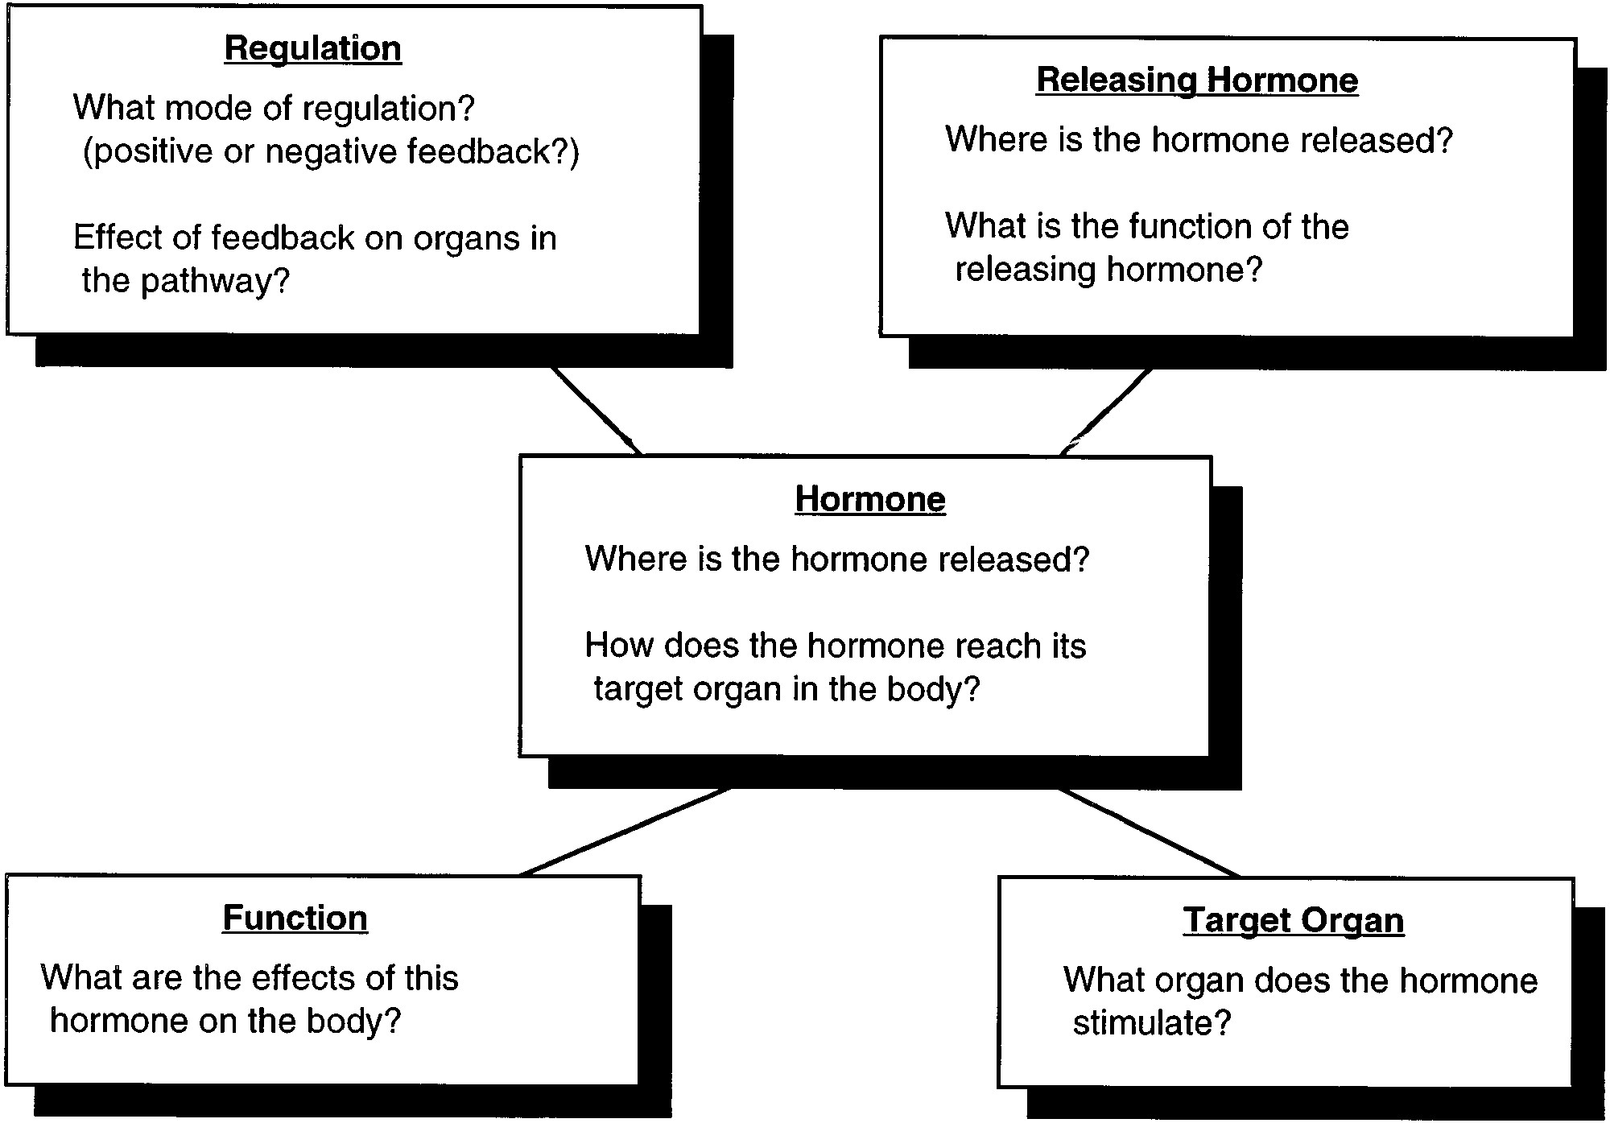
FIG. 5.
Concept map of background endocrine physiology.

