Figure 4. An isometric muscle twitch.
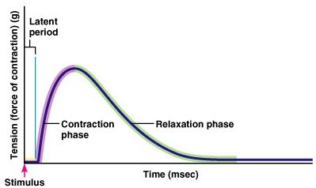
From Germann, 1st edition.

