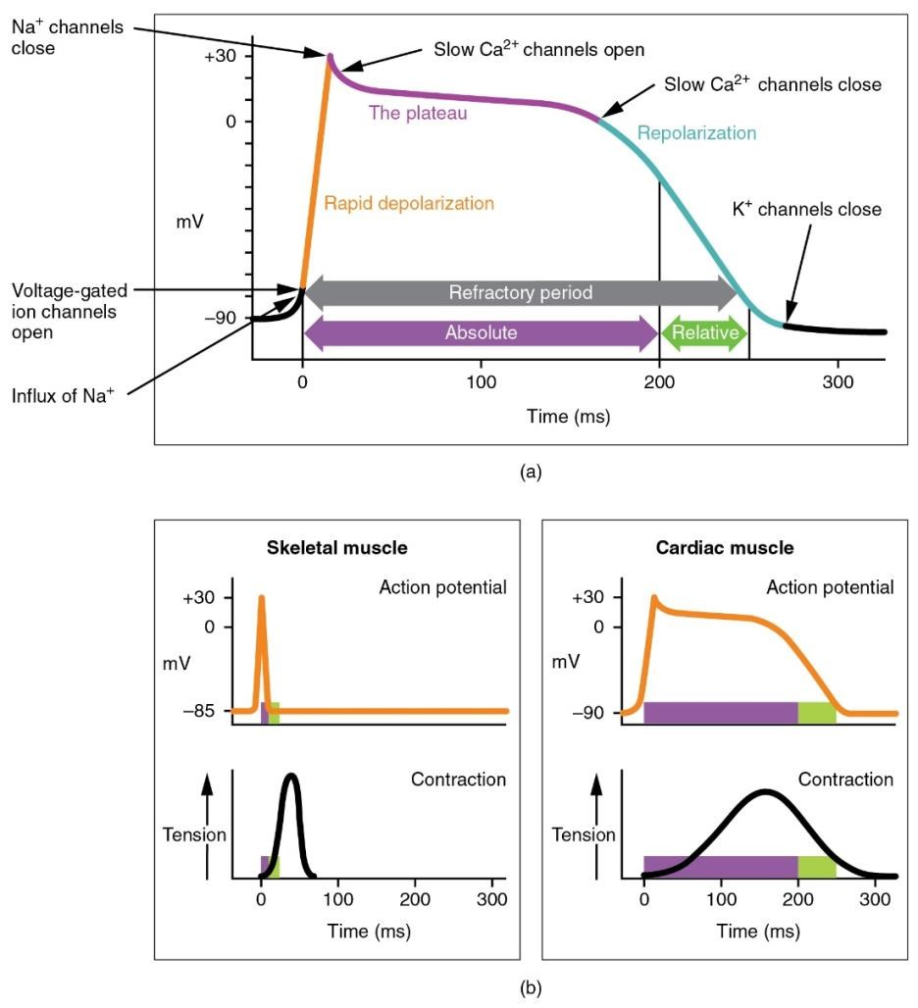
Figure 2: Action potential in cardiac contractile cells. (a) Note the long plateau phase due to the influx of calcium ions. The extended refractory period allows the cell to fully contract before another electrical event can occur. (b) The action potential for heart muscle is compared to that of skeletal muscle.
Credit: Openstax Anatomy and Physiology

