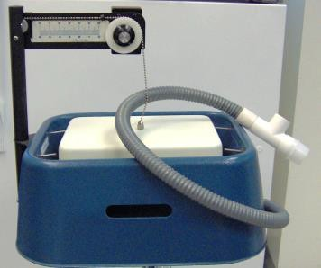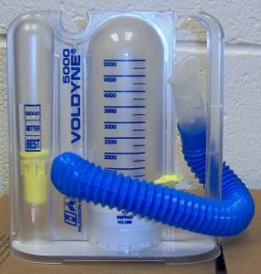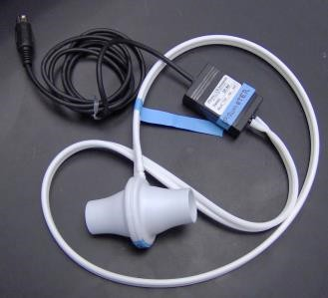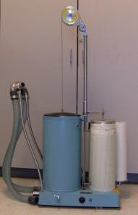
Figure 1. Various instruments used to measure lung volumes and oxygen consumption.
A. wet spirometer, B. dry spirometer, C. flow mouthpiece used by the IWorx System D. Sanborn respirometer

