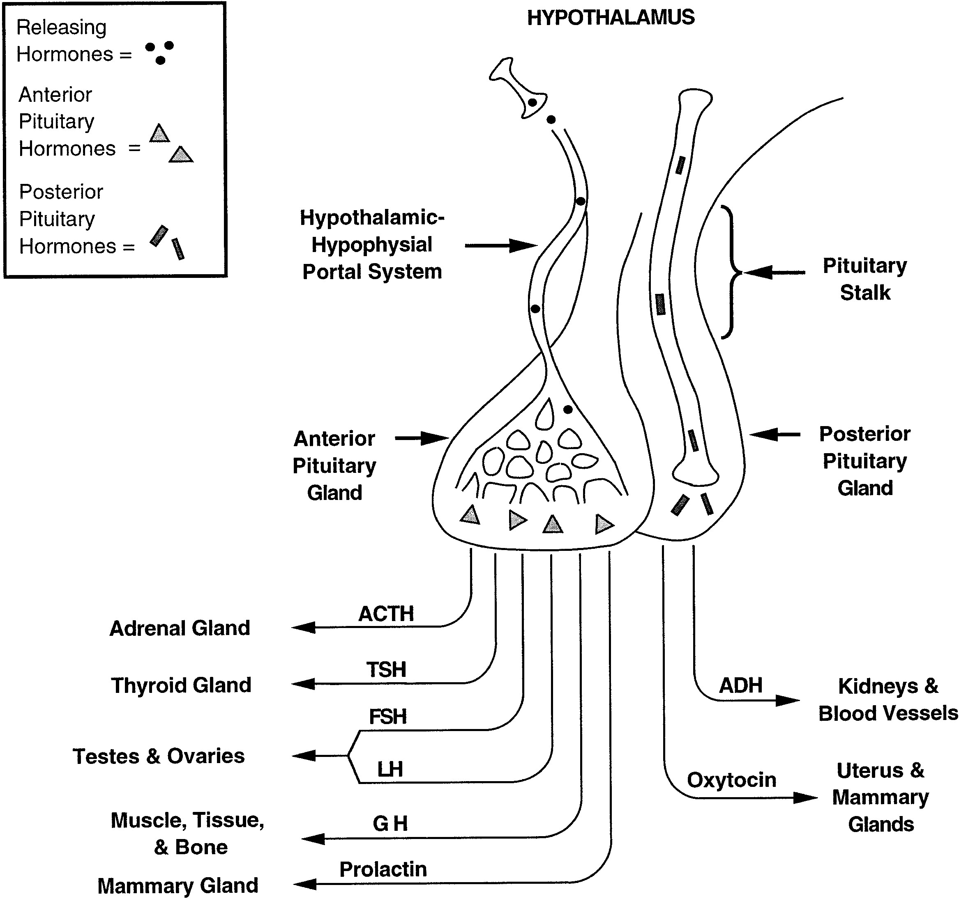
FIG. 1.
Secretion of hypothalamic hormones. Hypothalamic releasing hormones travel down the hypophyseal portal system to the anterior pituitary gland, where they stimulate the synthesis and release of anterior pituitary hormones [adrenocorticotropin hormone (ACTH), thyroid-stimulating hormone (TSH), follicle-stimulating hormone (FSH), luteinizing hormone (LH), growth hormone (GH), and prolactin]. In contrast, the posterior pituitary gland does not require releasing hormones, because the hypothalamus synthesizes and secretes both anti-diuretic hormone (ADH) and oxytocin.

