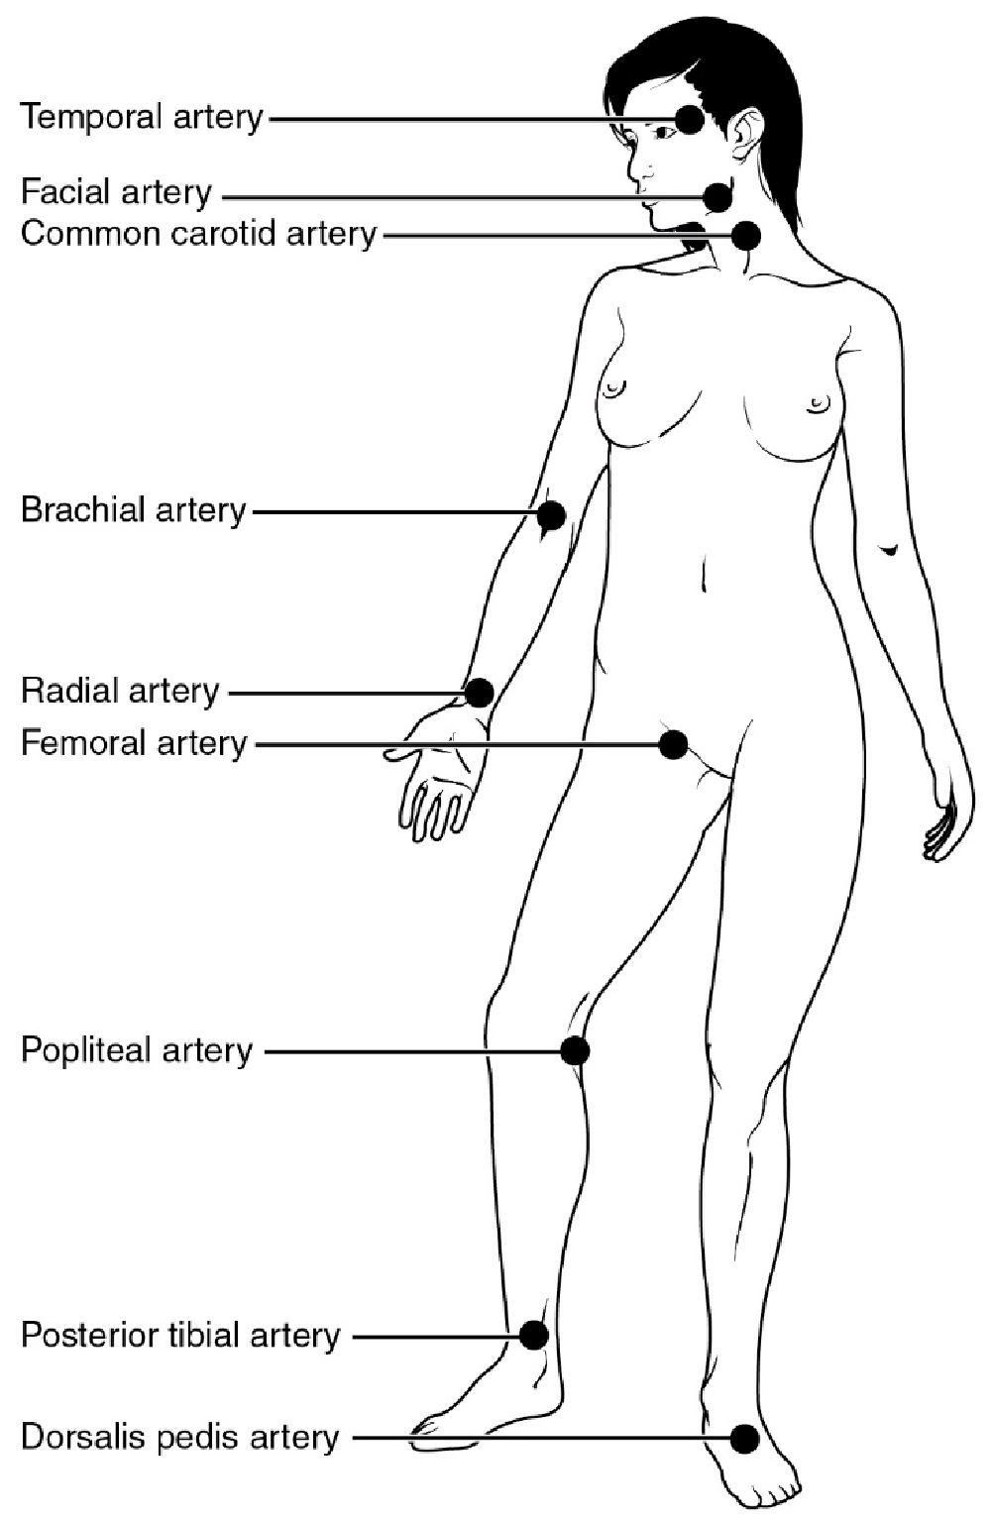
Figure 5. The pulse is most readily measured at the radial artery, but can be measured at any of the pulse points shown. Credit: Openstax Anatomy & Physiology

