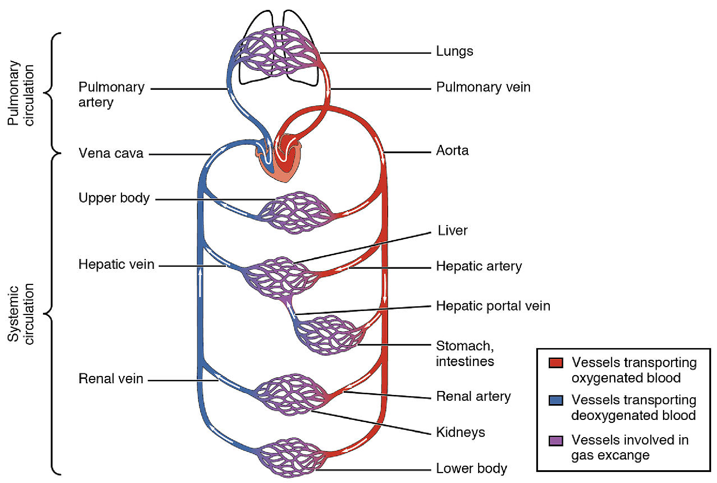
Figure 1. Diagram of the pulmonary and systemic circuits. Credit: Openstax Biology

