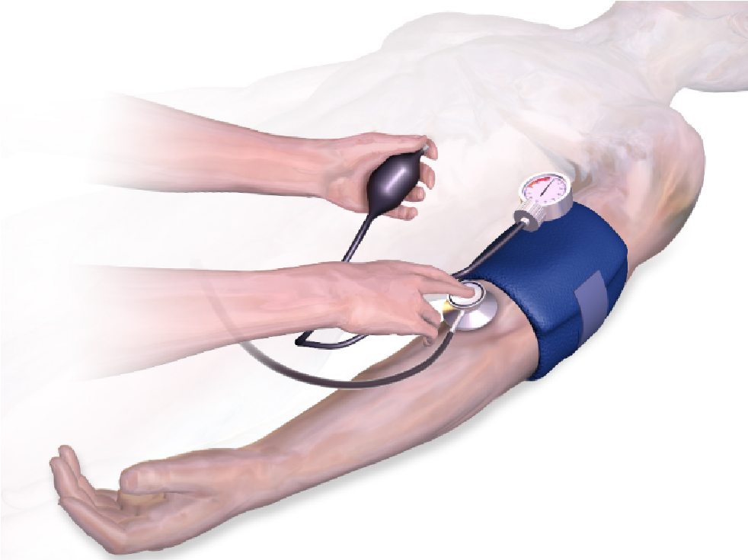
Figure 3. Measuring blood pressure indirectly. Credit: Bruce Blaus - own work, CC BY-SA 4.0, https://commons.wikimedia.org/w/index.php?curid=47242985

