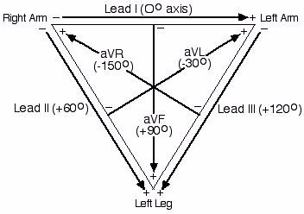
Figure 4: Einthoven’s triangle.

