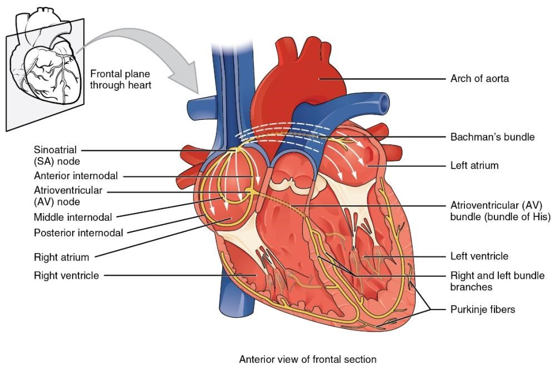
Figure 1. Specialized conducting components of the heart include the sinoatrial (SA) node, the atrioventricular (AV) node, the bundle of His, the right and left bundle branches, and the Purkinje fibers.
Credit: Openstax Anatomy and Physiology

