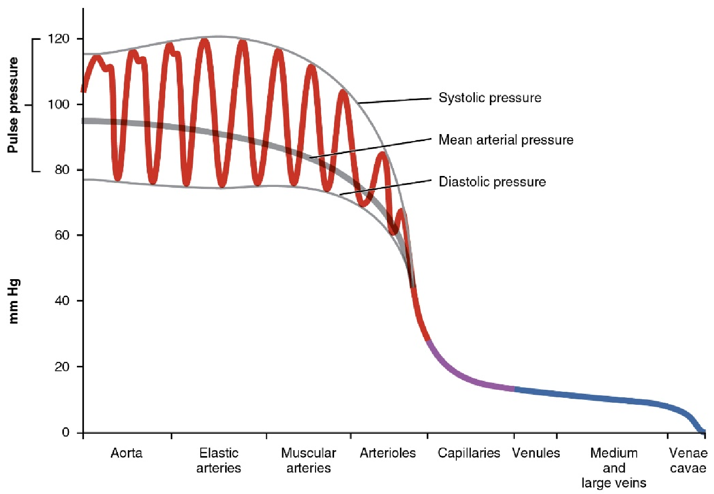

Figure 2. The graph shows the components of blood pressure throughout the blood vessels, including systolic, diastolic, mean arterial, and pulse pressures. Credit: Openstax Anatomy & Physiology

